**VIVEKANAND EDUCATION SOCIETY’S INSTITUTE OF TECHNOLOGY**

**An Autonomous Institute Affiliated to University of Mumbai**

**Department of Computer Engineering**



Project Report on

SmartServe: An AI-Powered Smart Bulk Food Ordering System with Bidding and QR-Based Feedback Integration

In partial fulfillment of the Fourth Year, Bachelor of Engineering (B.E.) Degree in Computer Engineering at the University of Mumbai Academic Year 2024-25

**Submitted by**

Vishakha Mangtani (D17-B, 29)

Ketan Paryani (D17-B, 37)

Ruchir Jain (D17-B, 18)

**Project Mentor**

Mrs. Yugchhaya Galphat

(2024-25)

**VIVEKANAND EDUCATION SOCIETY’S INSTITUTE OF TECHNOLOGY**

**An Autonomous Institute Affiliated to University of Mumbai**

**Department of Computer Engineering**



**Certificate**

This is to certify that ***Vishakha Mangtani, Ketan Paryani, Ruchir Jain*** of Fourth Year Computer Engineering studying under the University of Mumbai have satisfactorily completed the project on “***SmartServe: An AI-Powered Smart Bulk Food Ordering System with Bidding and QR-Based Feedback Integration***” as a part of their coursework of PROJECT-II for Semester-VIII under the guidance of their mentor ***Mrs. Yugchhaya Galphat*** in the year 2024-25 .

This project report entitled ***SmartServe: An AI-Powered Smart Bulk Food Ordering System with Bidding and QR-Based Feedback Integration*** by ***Vishakha Mangtani, Ketan Paryani, Ruchir Jain*** is approved for the degree of ***Bachelor of Engineering in Computer Engineering***.

| Programme Outcomes | Grade |
| --- | --- |
| PO1,PO2,PO3,PO4,PO5,PO6,PO7,  PO8, PO9, PO10, PO11, PO12  PSO1, PSO2 |  |

Date: April 28, 2025

Project Guide: Mrs. Yugchhaya Galphat

--------------------------------------

**Project Report Approval**

**For**

**B. E (Computer Engineering)**

This project report entitled ***SmartServe: An AI-Powered Smart Bulk Food Ordering System with Bidding and QR-Based Feedback Integration*** by ***Vishakha Mangtani, Ketan Paryani, Ruchir Jain*** is approved for the degree of ***Bachelor of Engineering in Computer Engineering***.

Internal Examiner

---------------------------------------------

External Examiner

---------------------------------------------

Head of the Department

-----------------------------------------------

Principal

-----------------------------------------------

Date: April 28, 2025

Place: VESIT, Mumbai

**Declaration**

We declare that this written submission represents our ideas in our own words and where others' ideas or words have been included, we have adequately cited and referenced the original sources. We also declare that we have adhered to all principles of academic honesty and integrity and have not misrepresented or fabricated or falsified any idea/data/fact/source in our submission. We understand that any violation of the above will be cause for disciplinary action by the Institute and can also evoke penal action from the sources which have thus not been properly cited or from whom proper permission has not been taken when needed.

| -----------------------------------------  Vishakha Mangtani (D17B/29) | -----------------------------------------  Ketan Paryani (D17B/37) |
| --- | --- |
| -----------------------------------------  Ruchir Jain (D17B/18) |  |

Date: April 28, 2025

**ACKNOWLEDGEMENT**

We are thankful to our college Vivekanand Education Society’s Institute of Technology for considering our project and extending help at all stages needed during our work of collecting information regarding the project.

It gives us immense pleasure to express our deep and sincere gratitude to our Assistant Professor

**Mrs. Yugchhaya Galphat** for her kind help and valuable advice during the development of project synopsis and for her guidance and suggestions.

We are deeply indebted to Head of the Computer Department **Dr.(Mrs.) Nupur Giri** and our Principal **Dr. (Mrs.) J.M. Nair,** for giving us this valuable opportunity to do this project.

We express our hearty thanks to them for their assistance without which it would have been difficult in finishing this project synopsis and project review successfully.

We convey our deep sense of gratitude to all teaching and non-teaching staff for their constant encouragement, support and selfless help throughout the project work. It is a great pleasure to acknowledge the help and suggestion, which we received from the Department of Computer Engineering.

We wish to express our profound thanks to all those who helped us in gathering information about the project. Our families too have provided moral support and encouragement several times

**Computer Engineering Department**

**COURSE OUTCOMES FOR B.E PROJECT**

Learners will be to,

| **Course Outcome** | **Description of the Course Outcome** |
| --- | --- |
| CO 1 | Able to apply the relevant engineering concepts, knowledge and skills towards the project. |
| CO2 | Able to identify, formulate and interpret the various relevant research papers and to determine the problem. |
| CO 3 | Able to apply the engineering concepts towards designing solutions for the problem. |
| CO 4 | Able to interpret the data and datasets to be utilized. |
| CO 5 | Able to create, select and apply appropriate technologies, techniques, resources and tools for the project. |
| CO 6 | Able to apply ethical, professional policies and principles towards societal, environmental, safety and cultural benefit. |
| CO 7 | Able to function effectively as an individual, and as a member of a team, allocating roles with clear lines of responsibility and accountability. |
| CO 8 | Able to write effective reports, design documents and make effective presentations. |
| CO 9 | Able to apply engineering and management principles to the project as a team member. |
| CO 10 | Able to apply the project domain knowledge to sharpen one’s competency. |
| CO 11 | Able to develop professional, presentational, balanced and structured approach towards project development. |
| CO 12 | Able to adopt skills, languages, environment and platforms for creating innovative solutions for the project. |

**Index**

| **Sr. No.** | **Title** | **Page No.** |
| --- | --- | --- |
| **1.** | **Chapter 1: Introduction**  1.1. Introduction  1.2. Motivation  1.3. Problem Definition  1.4. Existing Systems  1.5. Lacuna of the existing systems  1.6. Relevance of the Project | **11** |
| **2.** | **Chapter 2: Literature Survey**  A. Brief Overview of Literature Survey  B. Related Works  2.1. Research Papers Referred  a. Abstract of the research paper  b. Inference drawn  2.2. Patent search Links  1. European Patent  2. US patent  2.3. Inference drawn  2.4. Comparison with the existing system | **17** |
| **3.** | **Chapter 3: Requirement Gathering for the Proposed System**  3.1. Introduction to requirement gathering  3.2. Functional Requirements  3.3. Non-Functional Requirements  3.4. Hardware, Software , Technology and tools utilized  3.5. Constraints | **26** |
| **4.** | **Chapter** **4: Proposed Design**  4.1. Block diagram of the system  4.2. Project Scheduling & Tracking using Timeline / Gantt Chart | **33** |
| **5.** | **Chapter 5: Implementation of the Proposed System**  5.1. Methodology employed for development  5.2. Algorithms and flowcharts for the respective modules developed  5.3. Datasets source and utilization | **35** |
| **6.** | **Chapter 6: Testing of the Proposed System**  6.1. Introduction to testing  6.2. Types of tests Considered  6.3 Various test case scenarios considered  6.4. Inference drawn from the test cases | **44** |
| **7.** | **Chapter 7: Results and Discussion**  7.1. Screenshots of User Interface (UI) for the respective module  7.2. Performance Evaluation measures  7.3. Input Parameters / Features considered  7.4. Comparison of results with existing systems  7.5. Inference drawn | **47** |
| **8.** | **Chapter 8: Conclusion**  8.1. Limitations  8.2. Conclusion  8.3. Future Scope | **57** |
|  | **References** | **60** |
|  | **Appendix**  **1. Paper I**  A. Paper I  B. Plagiarism Report of Paper I  C. Project review sheet | **63** |

**List of Figures**

| **Fig No.** | **Figure Name** | **Page no.** |
| --- | --- | --- |
| 1 | Block Diagram of SmartServe | 33 |
| 2 | Project Scheduling and Tracking using Gantt Chart | 34 |
| 3 | Modular Flowchart for Bidding Process | 39 |
| 4 | Modular Flowchart of AI based Recommendation System | 40 |
| 5 | Modular Flowchart of ChatBot | 41 |
| 6 | Modular Flowchart of QR based Feedback Collection | 42 |
| 7 | Screenshot of User HomePage - I | 47 |
| 8 | Screenshot of User HomePage - II | 47 |
| 9 | Screenshot of Restaurant List and Menu | 48 |
| 10 | Screenshot of Restaurant Query Form | 48 |
| 11 | Screenshot of Chatbot | 49 |
| 12 | Screenshot of Order History Page | 49 |
| 13 | Screenshot of Bidding Acceptance | 50 |
| 14 | Screenshot of Admin Features | 50 |
| 15 | Screenshot of Adding Items in Menu for Restaurant | 51 |
| 16 | Screenshot of Order Details Page for Restaurant | 51 |
| 17 | Screenshot of Bidding Orders for Restaurant | 52 |
| 18 | Screenshot of Dashboard for RestaurantI | 52 |
| 19 | Screenshot of feedbacks for Restaurant | 53 |

**List of tables**

| **Sr. No.** | **Table Name** | **Page no.** |
| --- | --- | --- |
| 1 | Comparison with other Competitors | 25 |
| 2 | Performance Evaluation Measures | 52 |
| 3 | Input Parameters/Features Considered | 55 |
| 4 | Comparison of Results with Existing Systems | 56 |

**Abstract**

In the contemporary food service industry, particularly in the domain of bulk ordering from restaurants, the absence of a structured and competitive pricing mechanism has led to several inefficiencies. Customers often struggle to receive the best value for their money, while restaurant owners face challenges in standing out within fixed-price platforms. Existing systems predominantly follow a static pricing model, which restricts flexibility and does not adequately account for varying quality levels, customer preferences, or cost-effectiveness.

To overcome these challenges, this paper introduces SmartServe, an intelligent and dynamic bulk ordering system designed specifically for restaurant services. At its core, SmartServe employs an AI-powered bidding mechanism, allowing multiple restaurants to submit competitive bids for customer order requests. These bids are evaluated not only on pricing but also on service quality, ensuring a balanced price-to-quality ratio that benefits both parties.

In addition to the bidding system, SmartServe integrates a recommendation engine and a chatbot interface. These components use historical order data, customer preferences, and feedback to offer personalized suggestions and streamline the ordering experience. This level of personalization improves customer satisfaction and increases the chances of successful conversions for restaurants.

A noteworthy feature of SmartServe is its QR-based feedback system, which enables customers to scan a QR code provided on the bill and give real-time feedback after the order is completed. This feedback is used to continuously train the recommendation engine and refine future bidding outcomes, ensuring that quality remains a central factor in the decision-making process.

Implementation and testing of the system demonstrate that SmartServe significantly enhances the efficiency of the bulk ordering process, reduces costs for customers, and fosters higher engagement and visibility for restaurants. By introducing intelligent competition and personalized support, SmartServe redefines the restaurant bulk ordering experience for all stakeholders.

**1. Introduction**

**1.1 Introduction**

In the rapidly transforming food industry, digital innovation and shifting consumer expectations are reshaping how food services operate. The global food market, valued at $56 billion in 2021, is projected to grow at a compound annual growth rate (CAGR) of 9% through 2025[1]. This surge is driven by increasing demand for convenience, personalization, and faster service delivery. Platforms like Zomato, Swiggy, and Uber Eats have effectively capitalized on this by offering seamless individual food ordering and delivery experiences [2]. However, these platforms primarily focus on single-user transactions and lack robust solutions for bulk food ordering, an essential requirement for corporate events, institutional functions, and large group gatherings. This segment remains underserved, with customers often relying on manual communication and traditional methods that are time-consuming and inefficient [3].

Existing bulk ordering platforms such as CaterNinja attempt to address this need but are limited in scope. They typically offer static menus and fixed pricing, without incorporating dynamic decision-making or intelligent personalization [4]. Customers frequently report dissatisfaction due to lack of pricing transparency, absence of comparative choices, and restricted customization. Furthermore, while QR code technology is increasingly being used in the food service space, its application is mostly confined to digital menus or contactless payments, offering little functional value in enhancing service feedback or learning capabilities within the system [5]. As a result, the potential of data-driven, user-centric bulk ordering remains largely untapped in the current market scenario.

To address these limitations, SmartServe is introduced as a next-generation, AI-enabled platform designed specifically for bulk food ordering. At the core of SmartServe is a real-time bidding system that allows restaurants to actively compete for customer orders based on price and quality, creating a transparent and competitive marketplace [6]. This ensures that customers receive the best value without the need for manual negotiation. In addition, the system integrates an AI-powered recommendation engine that uses past order data, feedback, and user preferences to personalize suggestions and improve decision-making [7]. A built-in chatbot assistant further enhances the customer experience by offering real-time support, guidance during the ordering process, and interactive responses tailored to individual users [8].

A standout feature of SmartServe is its QR-based feedback mechanism, which encourages customers to provide immediate post-order feedback by scanning a code on their bill. This feedback is not merely collected but is actively analyzed and incorporated into the system’s recommendation and bidding logic, making it smarter over time [9]. Through this feedback loop, restaurants are incentivized to maintain service quality, and users benefit from increasingly accurate and relevant suggestions. By bringing together automation, competition, and intelligent personalization, SmartServe offers a transformative solution for the bulk ordering space empowering users with better choices and enabling restaurants to thrive through data-driven engagement.

**1.2 Motivation**

The motivation behind developing SmartServe stems from the evident gap in the current food delivery ecosystem when it comes to bulk ordering. While individual food delivery has seen rapid digitalization and automation through platforms like Zomato and Swiggy, the bulk ordering domain still relies heavily on manual communication, fixed pricing, and lacks transparency in both cost and quality. Users looking to place large orders for corporate events, institutions, or social gatherings often face limited choices, time-consuming coordination, and inconsistent service quality.

Moreover, existing platforms do not offer any intelligent mechanism to compare restaurants dynamically or allow customers to receive competitive quotes. There is also a lack of personalized recommendations and real-time assistance during the ordering process. Additionally, the potential of feedback systems is underutilized—QR codes are mostly used for menus or payments, not for improving future recommendations or service quality through analytics.

These limitations served as the primary driving force for creating an AI-powered platform like SmartServe. The aim was to introduce a system where restaurants could bid competitively based on price and quality, while customers benefit from transparent decision-making, personalized suggestions, and an improved user experience through chatbot assistance and QR-based feedback. The project was driven by the vision to bring efficiency, intelligence, and fairness into the bulk ordering space—transforming it into a data-driven and user-centric process.

**1.3 Problem Definition**

Despite the rapid growth of online food delivery platforms, the process of bulk food ordering remains inefficient, outdated, and highly manual. Existing platforms mainly cater to individual food orders, offering limited functionality for users who need to place large orders for events, institutions, or group gatherings. Customers are often required to contact multiple restaurants manually, compare fixed menus, and negotiate prices without any real-time visibility into competitive offerings.

Additionally, there is no structured bidding system in place where restaurants can compete for customer orders based on pricing, quality, or delivery timelines. This lack of competition leads to non-transparent pricing and limited customer choice. Furthermore, current systems do not leverage user data to offer personalized recommendations, nor do they provide intelligent chatbot assistance to guide customers through the bulk ordering process.

Another major gap is in the use of customer feedback. While QR codes are widely adopted in food services, they are primarily used for payments or menu display, with minimal integration into feedback-driven service improvement. As a result, the overall user experience remains rigid, time-consuming, and non-adaptive.

The problem, therefore, lies in the absence of a smart, data-driven platform that combines real-time bidding, personalized recommendations, chatbot interaction, and dynamic feedback integration to streamline and enhance the bulk food ordering process for both customers and restaurants.

**1.4 Existing Systems**

With the rise of digital transformation in the food service industry, various platforms have emerged to simplify food ordering and delivery. Applications like Zomato, Swiggy, and UberEats have successfully addressed the needs of individual consumers, offering features like real-time order tracking, digital payments, and curated menus. These systems are designed for speed, convenience, and scalability when it comes to personal meal deliveries. However, despite their technological advancements, they lack the infrastructure and intelligence needed for bulk ordering, which involves a completely different set of requirements, such as negotiation, pricing flexibility, and vendor coordination.

Some platforms like CaterNinja, EzCater, and other regional services attempt to cater to large-scale food orders for events or corporate needs. While they fill a certain gap in the market, their systems are largely static and menu-based, offering limited personalization and fixed pricing. Customers are unable to benefit from real-time competitive offers from multiple restaurants, and the ordering process remains time-consuming and manually intensive. There is no concept of restaurant bidding, and decisions are made without access to comparative data on pricing or quality.

Moreover, the use of technologies like AI-based recommendation systems, interactive chatbots, and smart feedback integration is either missing or extremely limited in these platforms. QR codes, if used, are generally restricted to accessing menus or making payments, with no role in feedback collection or system improvement. As a result, customer experiences are generic, repetitive, and lack adaptability based on preferences or past interactions.

These limitations reflect a clear gap in the current market for an intelligent, automated, and competitive bulk ordering system. Existing platforms are not equipped to deliver the kind of dynamic, user-driven experience that modern customers demand. This gap paves the way for SmartServe, a platform designed to redefine bulk food ordering through real-time bidding, personalized AI features, and feedback-driven refinement.

**1.5 Lacuna of the existing systems**

Despite the rapid evolution of food delivery platforms and their success in optimizing single-order transactions, the bulk food ordering segment remains largely underserved and inefficient. Current systems, while effective for individual meal deliveries, fail to address the unique needs of large-scale orders required by events, institutions, and group gatherings. The absence of dynamic, intelligent features leads to a fragmented and tedious process, which fails to leverage modern technologies to improve customer experience and service efficiency.

A primary lacuna in existing platforms is the lack of real-time competitive bidding. In traditional systems, restaurants are presented with fixed pricing and static menus, making it impossible for them to compete for bulk orders based on price or service quality. This results in non-transparent pricing for customers and limits their ability to choose the best vendor based on both cost and quality. Furthermore, without the ability to compare offers from multiple restaurants in real time, the decision-making process becomes cumbersome and slow, leading to delays in fulfilling large orders.

Another significant shortcoming is the absence of personalized user experiences. Existing systems lack AI-driven recommendation engines, which means customers are often presented with generic options that don’t meet their specific needs or preferences. This leads to a repetitive, uninspiring ordering experience, where choices are limited and not tailored to past behaviors or feedback. Similarly, the absence of interactive chatbots leaves users without real-time assistance during the ordering process, further hindering user satisfaction and engagement.

Finally, current systems fail to harness the full potential of customer feedback. While QR codes are widely used for contactless menus and payments, their potential to collect real-time feedback and influence system improvements is largely ignored. Without a smart feedback loop, platforms cannot refine their algorithms, improve vendor recommendations, or adapt to changing customer preferences. This limits the overall effectiveness of the service and inhibits continuous improvement.

These critical gaps in the existing systems underline the pressing need for a platform like SmartServe, which brings together AI-powered bidding, personalized recommendations, chatbot support, and a feedback-driven ecosystem to revolutionize bulk food ordering for both customers and restaurants.

**1.6 Relevance of the Project**

The SmartServe project is highly relevant in the current landscape of the food service industry, where the demand for bulk food ordering is growing rapidly. As the global food market continues to expand, particularly in the context of corporate events, educational institutions, and large gatherings, there is an increasing need for systems that can streamline and optimize the bulk ordering process. Existing platforms, while successful in handling individual orders, fail to address the complexities of large-scale orders—a segment that requires flexibility, competitive pricing, and intelligent decision-making.

The relevance of SmartServe lies in its ability to provide a dynamic and intelligent solution to a traditionally underserved market. By introducing a real-time bidding mechanism, SmartServe fosters healthy competition among restaurants, allowing them to compete on price and quality. This ensures that customers have access to the best value for their bulk orders, thus improving cost-effectiveness for both the customers and restaurant owners. Furthermore, by leveraging AI-driven recommendation engines and an interactive chatbot, SmartServe offers personalized suggestions that enhance user experience and simplify the decision-making process.

The QR-based feedback system integrates real-time customer reviews, ensuring continuous improvement in service quality and customer satisfaction. As platforms continue to evolve, the need for systems that can analyze data, adapt to preferences, and improve efficiency becomes crucial. SmartServe not only addresses these needs but also contributes to the broader goal of digital transformation in the food service industry by making bulk ordering more intelligent, transparent, and user-centric.

Moreover, the project aligns with the growing interest in data-driven decision-making, automation, and the use of AI to enhance business processes, making it highly relevant in today's tech-driven food industry. By bridging the gap between restaurant owners and customers through automated bidding, feedback loops, and personalized services, SmartServe is poised to transform the way bulk food orders are placed and fulfilled, marking it as a highly relevant and forward-thinking solution.

**2. Literature Survey**

**A. Brief Overview of Literature Survey**

The digital transformation of the food industry is reshaping how restaurants operate, engage with customers, and manage internal processes. As consumer expectations continue to evolve, businesses are increasingly adopting advanced technologies to remain competitive. From QR code-based systems to AI-powered chatbots and intelligent recommendation engines, these technological innovations are streamlining restaurant operations, enhancing service quality, and providing consumers with smarter, more personalized experiences. As the food service industry embraces these technologies, it’s becoming increasingly clear that data-driven solutions are playing a critical role in transforming the customer experience and improving operational efficiencies.

One of the key drivers of change in the food service industry is the demand for automation, convenience, and personalization. According to Thomas and Patel [1], the digital food services sector is projected to grow at a 9% compound annual growth rate (CAGR) from 2021 to 2025, as businesses seek innovative ways to enhance their services. This growth is being driven by consumer demand for faster, more efficient, and personalized experiences. A major innovation in this space is the implementation of QR code systems, which are gaining traction for their ability to streamline service delivery and enhance customer interaction. Čović et al. [10] highlighted the use of QR codes in electronic market research, showing their ability to improve data collection and accelerate feedback processes. Similarly, Khan [2] extended the utility of QR codes by integrating them into a cloud-based expiry tracking system, thus improving food safety and inventory control. This advancement demonstrates the adaptability of QR codes, which can serve not only as a tool for customer engagement but also as a key component in back-end operations.

Further exploring the potential of QR codes in customer interaction, Wahsheh and Al-Zahrani [3] investigated QR code security in healthcare applications, offering insights that could be applied to secure restaurant feedback systems. Alkhayyat et al. [4] further demonstrated the effectiveness of QR codes by developing a platform that allowed for real-time feedback collection, directly improving customer satisfaction and response times from restaurant staff. These applications are particularly relevant for bulk order scenarios, where real-time insights can significantly impact service optimization.

The ability to process feedback and personalize experiences is another significant trend in the food service industry. With the rise of AI-driven recommendation engines, platforms can offer more tailored suggestions to users, making their dining experience more relevant and engaging. For instance, Wu et al. [9] utilized QR decomposition to analyze textual reviews and provide personalized restaurant suggestions based on past preferences. This application of feedback processing is complemented by the use of AI-powered chatbots, which are increasingly becoming a central feature of digital customer service in the food industry. Dutt et al. [5] developed a chatbot for dynamic information retrieval, which could respond quickly to customer inquiries, offering a fast, personalized service experience. Gupta et al. [6] applied similar AI chatbot technology to streamline restaurant ordering, further simplifying the customer experience. Garg et al. [8] extended these capabilities by developing a Natural Language Processing (NLP)-based chatbot that could handle multiple orders simultaneously, significantly improving service accuracy and customer satisfaction.

At the operational level, systems designed to optimize real-time operations are gaining ground. Ardiansyah et al. [7] developed a real-time food booking platform aimed at minimizing wait times and streamlining the order fulfillment process. These types of systems are a direct reflection of the shift toward real-time responsiveness, which Thomas and Patel [1] identified as a key factor driving the market’s growth. By allowing customers to place and track orders instantly, these platforms reduce the friction often associated with traditional bulk order processing, providing more timely and efficient service.

Beyond the customer-facing applications, digital tools are also enhancing the strategic operations of restaurants. Wei and Guo [11] proposed a bid evaluation model designed to improve cost-efficiency and fairness in vendor selection, principles directly applicable to the food service industry, where competitive bidding for bulk orders could significantly enhance the decision-making process. By introducing a transparent, data-driven mechanism for restaurant selection, such systems can ensure that both customers and restaurants benefit from fair pricing and optimal service delivery.

A more unified approach to these innovations is evident in the work of V.N.A. et al. [12], who introduced a prompt-based recommendation system that combines the capabilities of AI chatbots with feedback summarization. This type of system exemplifies the food service industry's shift towards intelligent, customer-centric automation, where multiple technologies work in tandem to create a seamless and personalized experience for both customers and restaurant owners.

Despite the growing number of digital innovations in the food service sector, current systems still have several limitations that hinder optimal restaurant operations and customer experiences. One major gap is the lack of actionable insights from customer feedback. Existing feedback mechanisms are generally consumer-focused and do not provide restaurants with the tools to optimize their operations or improve service quality. Additionally, there is an absence of personalized recommendations based on order history, preventing systems from offering more relevant suggestions to users. The lack of dynamic pricing and automated bidding for bulk orders remains a critical issue, as it limits restaurants' ability to compete effectively for high-volume orders and reduces the potential for cost optimization. These deficiencies prevent the creation of a win-win situation for both consumers and restaurants, highlighting the need for an integrated system that addresses these gaps.

**B. Related Works**

The growing demand for personalized experiences and efficient service in the food service industry has led to the development of various platforms that leverage technology to improve customer engagement and operational processes. A significant body of research focuses on technologies such as QR codes, chatbots, AI-driven recommendation systems, and real-time bidding mechanisms to optimize bulk ordering and restaurant management. While these innovations offer promising results, several gaps remain in addressing the complex needs of bulk food orders.

One of the most significant advancements in restaurant technology has been the implementation of QR code-based systems. These systems have been widely adopted for contactless payment and menu browsing but are also being explored for more dynamic uses, such as real-time feedback collection. For instance, Alkhayyat et al. [4] proposed a platform that allows customers to provide feedback through a QR code system, enabling restaurants to collect real-time insights into customer satisfaction. This approach is further supported by Čović et al. [10], who demonstrated the utility of QR codes in gathering consumer data for market research, helping businesses adapt their offerings based on customer preferences. Such systems, however, still lack the integration of customer feedback into a broader personalized service strategy that could help businesses optimize their service offerings based on data analysis.

Another area of interest is the use of AI chatbots in improving customer experience and operational efficiency. Dutt et al. [5] introduced a dynamic chatbot for retrieving real-time information, helping customers quickly find answers to their queries and reducing response times. In the context of food service, Gupta et al. [6] applied AI chatbots to streamline the restaurant ordering process. Their chatbot system was designed to understand customer orders and process them with minimal human intervention, improving order accuracy and customer satisfaction. Similarly, Garg et al. [8] developed an NLP-based chatbot that could handle multiple orders simultaneously, significantly enhancing the system’s ability to process bulk orders with higher accuracy and efficiency. While these systems represent notable improvements in customer service, they often lack features like personalization and order history integration, which are crucial for delivering tailored experiences, especially in bulk ordering scenarios.

Real-time bidding systems have also been explored in several domains, with the aim of enhancing pricing transparency and competition. Wei and Guo [11] proposed a bid evaluation model to ensure fairness and cost-efficiency in vendor selection, a concept that is highly applicable to the food service industry. This model allows businesses to compare multiple bids based on predefined criteria, which can be particularly beneficial for bulk ordering in the food industry, where price competitiveness is key to customer satisfaction. However, these systems have been limited to smaller-scale applications and have not yet been widely implemented in restaurant bulk ordering platforms, which tend to rely on fixed pricing models rather than dynamic bidding.

Several studies have also explored the use of feedback in personalizing customer experiences. Wu et al. [9] utilized QR decomposition to analyze textual reviews, allowing their recommendation system to suggest personalized restaurant options based on customer preferences and past order history. This method of integrating customer feedback into the ordering process represents a step forward in personalization, but the lack of real-time integration in many existing systems limits their ability to offer immediate, actionable suggestions. The potential for improving recommendation accuracy through feedback and historical order analysis remains under-explored in current literature, especially in the context of bulk food ordering.

While there has been significant progress in developing these technologies, a key limitation remains the lack of integration across systems. Current platforms often offer individual functionalities (e.g., QR codes for feedback, AI chatbots for ordering, and static pricing models) but do not combine them into a cohesive solution. SmartServe aims to fill this gap by creating an integrated platform that combines real-time bidding, AI-driven recommendations, chatbots, and QR-based feedback in a seamless, user-friendly environment. This platform not only offers personalized experiences for individual customers but also enables restaurant owners to engage in dynamic competition based on price and service quality, improving both operational efficiency and customer satisfaction.

**2.1 Research Papers Referred**

[1] J. Thomas and R. Patel, "Growth Trends and Digital Transformation in the Global Food Market"  
Abstract:This paper analyzes the digital transformation of the global food market, projecting a 9% CAGR from 2021 to 2025. It focuses on technological advancements like automation, AI, and QR codes, which are reshaping how restaurants engage with customers. The paper emphasizes the importance of adopting digital tools for businesses to stay competitive and meet consumer demand for faster, smarter, and personalized service.

Inference:The paper highlights the accelerating digital transformation in the food industry, with an increasing shift towards automation and personalization. The SmartServe platform aligns with these trends by implementing a real-time bidding system and leveraging AI to meet customer expectations for personalization and convenience

[2]T. Khan, "A Cloud-Based Smart Expiry System Using QR Code"  
Abstract:Khan’s research presents a cloud-based system using QR codes to manage the expiry dates of food items in restaurants. This system helps reduce food waste and improve inventory management by providing real-time tracking of perishable items through QR code scanning. It highlights the use of QR codes for operational efficiency and food safety, ensuring that businesses can maintain fresh supplies and comply with health regulations.  
Inference:Khan’s work demonstrates how QR codes can enhance operational efficiency through real-time tracking. This concept directly influenced SmartServe's use of QR codes for feedback collection, ensuring restaurants can gather timely customer responses and refine their offerings based on real-time data.

[3]H. A. M. Wahsheh and M. S. Al-Zahrani, "Secure and Usable QR Codes for Healthcare Systems: The Case of Covid-19 Pandemic"  
Abstract:This paper explores the use of QR codes in the healthcare sector during the COVID-19 pandemic for secure and contactless data exchange. It addresses issues of security and usability, and how QR codes can be adapted for various sectors, including food services. The research emphasizes the importance of data privacy and security in contactless interactions, offering insights into integrating QR codes securely within restaurant feedback systems.

Inference:The emphasis on security and usability of QR codes in this research informed SmartServe’s design of a secure and user-friendly feedback mechanism. This aligns with SmartServe’s goal of using QR codes for not only feedback collection but also ensuring secure and efficient interactions between restaurants and customers.

[4]A. Alkhayyat, R. Kumar, S. Singh, R. Singh, Y. Kumar, and U. Sharma, "An Online QR Code Scanner for Real-Time User Feedback and Ratings Collection with Local Web Server"  
Abstract :This research introduces an online QR code scanning system for collecting real-time user feedback and ratings. The feedback is processed on a local server, allowing for immediate action to improve customer service. It demonstrates how QR codes can streamline the feedback collection process, which can be directly applied to enhancing customer interaction and service response in the restaurant industry.  
Inference:The real-time feedback collection approach from this study is mirrored in SmartServe’s QR code-based feedback system. By integrating local servers for immediate analysis, SmartServe can provide actionable insights to restaurants to improve customer service and adjust bids dynamically, benefiting both parties in bulk order scenarios.

[5]V. Dutt, S. M. Sasubilli, and A. E. Yerrapati, "Dynamic Information Retrieval With Chatbots: A Review of Artificial Intelligence Methodology"  
Abstract:This paper reviews AI methodologies for dynamic information retrieval through chatbots. It discusses how chatbots can offer personalized, fast, and accurate responses, improving user interactions across different platforms. The research focuses on the role of Natural Language Processing (NLP) and intent recognition in enhancing chatbot functionalities, providing a detailed look at how AI can be used to manage customer queries efficiently.

Inference:Dutt et al.'s review on dynamic information retrieval through AI-powered chatbots provides a foundation for SmartServe's chatbot system, which offers personalized recommendations based on historical data. The focus on NLP and intent recognition ensures that SmartServe's chatbot can handle complex customer queries and enhance the ordering experience.

**2.2 Patent search**

[1]US9117231B2 – Ordering Method and System for Restaurants

This patent describes a system where customers can place orders at restaurants by scanning a QR code on their table using a smartphone application. The QR code contains information such as the restaurant identifier and table number. Upon scanning, the app retrieves the appropriate menu for that time of day and allows customers to select items, add special instructions, and review their order before payment. The order is then sent directly to the kitchen, streamlining the ordering process and reducing wait times. ​[Google Patents](https://patents.google.com/patent/US9117231B2/en?utm_source=chatgpt.com)This system aligns with the trend of digitizing restaurant operations to enhance customer experience and operational efficiency. By integrating QR code scanning with mobile applications, restaurants can offer a seamless ordering process that minimizes human error and improves service speed.

[2]US10592706B2 – Artificially Intelligent Order Processing System  
This patent details an ordering system that utilizes advanced speech recognition technology to automate the ordering process in fast food and drive-through restaurants. The system can accurately recognize a wide vocabulary of words and associate tones and other metadata, facilitating a natural language interface for customers. This reduces the need for human staff to capture order data, streamlining the ordering process and improving efficiency. ​[Google Patents](https://patents.google.com/patent/US10592706B2/en?utm_source=chatgpt.com)

The integration of AI-driven speech recognition into the ordering process represents a significant advancement in customer service automation. By enabling customers to place orders using natural language, restaurants can enhance user experience, reduce wait times, and optimize labor resources.

**2.3. Inference drawn**

The patent search reveals significant advancements in digital transformation within the food service industry, particularly in the integration of QR code-based systems and AI-powered technologies. These patents provide a clear indication of how technology is reshaping ordering systems, enhancing customer experience, and optimizing restaurant operations.

1.Integration of QR Code Systems:

The US9117231B2 patent outlines a system where customers use QR codes to place orders directly from their smartphones. This simplifies the ordering process by reducing human error and wait times, which aligns with SmartServe’s use of QR codes for real-time feedback collection. This patent reinforces the importance of QR codes in automating and streamlining operations within the food service sector.

2.AI-Driven Ordering and Speech Recognition:

The US10592706B2 patent demonstrates how AI and speech recognition are transforming the order-taking process in restaurants. The system allows customers to place orders through a natural language interface, improving efficiency and reducing the reliance on human staff. This highlights the growing role of AI in personalizing customer interactions and automating processes, a trend that SmartServe capitalizes on through its AI-powered chatbot and dynamic recommendation engine.

3.Enhancing Customer Experience and Operational Efficiency:

Both patents emphasize the dual benefits of digital systems in improving customer experience while also increasing operational efficiency. SmartServe’s integration of AI-driven bidding, chatbots, and real-time feedback collection mirrors these advancements by offering customers personalized recommendations and ensuring fair pricing through a competitive bidding process.

4.Future Trends in Automation:

The focus on automation in both patents suggests that the food service industry is moving towards more intelligent, data-driven systems. SmartServe is aligned with this trend by implementing automated bidding and feedback systems, providing both customers and restaurants with actionable insights in real-time.

In summary, these patents emphasize the transformative power of digital technologies in the food industry, validating the approach of SmartServe in addressing gaps such as competitive pricing, transparency, and personalized customer experiences.

**2.4 Comparison with the existing system**

| **Feature** | **Swiggy & Zomato** | **CaterNinja** | **SmartServe** |
| --- | --- | --- | --- |
| Ordering Process | Single-restaurant ordering, delivery logistics | Bulk ordering for events, manual negotiation | Automated bidding process for bulk orders |
| Pricing Model | Fixed pricing, dynamic pricing during promotions | Fixed pricing, negotiation with restaurants | Dynamic pricing through competitive bidding |
| Recommendation System | Basic recommendations based on user preferences | Basic recommendations based on menu options | AI-powered recommendation engine based on order history and preferences |
| Feedback Mechanism | Ratings and reviews after order delivery | No real-time feedback mechanism | QR-based feedback integrated for continuous improvement |
| Customer Interaction | Limited, via app or customer service | Limited, manual communication with restaurants | AI-driven chatbots for personalized interactions |
| Efficiency in Order Fulfillment | Standard delivery times, manual intervention | Time-consuming manual order handling | Optimized order fulfillment with automated system |
| Transparency | Transparent menu and pricing | Limited transparency in bulk pricing and options | Transparent bidding process with clear pricing options |

*Table 1 :Comparison with other competitors*

**3. Requirement Gathering for the Proposed System**

**3.1 Introduction to requirement gathering**

The requirement gathering phase for SmartServe was centered on identifying the key expectations and challenges faced by various stakeholders involved in food ordering and customer feedback systems. The aim was to develop a unified platform that simplifies bulk ordering, streamlines feedback collection, and enhances customer interaction through automation. To ensure the system addresses real-world problems, information was collected through a mix of interviews, surveys, and competitor analysis.

Restaurant owners were consulted to understand their needs related to managing large group orders, automating quotations, and accessing meaningful feedback that could lead to service improvements. Customers and event organizers provided insights into their difficulties with current ordering systems, such as unclear communication with restaurants, lack of transparency in pricing, and the absence of a proper feedback mechanism. These inputs played a crucial role in shaping the features and user flows of the system.

Various requirement elicitation techniques were used to gather data effectively. Structured interviews helped uncover process-level challenges in restaurants, while user surveys highlighted preferences for features like QR-code based feedback and real-time support. Additionally, existing platforms were studied to identify gaps particularly in the areas of automated response systems and intelligent feedback analysis.

The requirements identified were broadly classified into functional and non-functional categories. Functional requirements included features like role-based user registration, modules for individual and bulk order placement, an automated quotation system, QR-based feedback forms, chatbot-driven customer support, and dashboards for analytics and reporting. Non-functional requirements focused on system performance, security, scalability, responsiveness, and user-friendliness. These specifications ensured that the platform would be accessible, secure, and capable of handling high traffic during peak usage.

**3.2. Functional Requirements**

Functional requirements detail the specific behaviors and capabilities that the SmartServe system must exhibit to meet user needs and provide a seamless experience. For the SmartServe platform, the functional requirements are outlined as follows:

1. User Registration/Login: Users must be able to create personal accounts and log in securely to the SmartServe platform. The registration process should include verifying the user’s email address and ensuring that sensitive information, such as passwords, is encrypted and securely stored. Users should also have the option to recover their passwords if they forget them.

2. Bulk Ordering: The platform must enable users to place bulk orders by allowing them to select multiple items from various restaurants seamlessly. Users should be able to specify quantities for each item and view an aggregated order summary. The system must automatically generate and send personalized quotes to users based on their selected items, taking into account factors such as restaurant pricing, delivery fees, and any applicable discounts. Additionally, users should be able to modify their orders before finalizing the purchase.

3. Feedback Collection:Each order processed through SmartServe must generate a unique QR code linked to a feedback submission form. This QR code should be included in order confirmation notifications sent to users. Users should be able to scan the QR code or click the link to easily access the feedback form, enabling them to provide feedback on their dining experience, the quality of the food, and the service received. The system should also allow users to leave suggestions for improvements.

4. AI Chatbot Integration: The SmartServe platform must feature an AI-powered chatbot capable of responding to a wide range of customer queries regarding menu items, order statuses, and available restaurant options. The chatbot should utilize Natural Language Processing (NLP) to understand and interpret user inquiries accurately. Furthermore, it must provide personalized recommendations based on users’ past orders and preferences, enhancing the customer experience by suggesting relevant menu items that align with their tastes.

5. Reporting and Analytics:The system should include a robust reporting and analytics module that generates insightful reports on customer feedback, ordering trends, and other key performance indicators. Restaurant owners should have access to dashboards displaying metrics related to customer satisfaction, popular menu items, and overall performance. This analytics feature will empower restaurant owners to make data-driven decisions, allowing them to adapt their offerings and improve service quality based on real-time feedback.

**3.3. Non-Functional Requirements**

Non-functional requirements define the quality attributes and constraints of the SmartServe system, ensuring it operates effectively and meets user expectations. These requirements cover various aspects such as performance, usability, reliability, and security, which are crucial for delivering a positive user experience and maintaining trust. For SmartServe, the non-functional requirements are as follows:

1. Performance: The SmartServe system must be capable of handling up to 1,000 simultaneous users without any noticeable performance degradation. This requirement is essential to ensure that the platform remains responsive, particularly during peak usage times, such as lunch and dinner hours. Additionally, the feedback processing system should operate in real-time, allowing users to see their feedback reflected immediately and enabling restaurant owners to access insights as they are collected.

2. Usability:The user interface (UI) of SmartServe must be designed with usability in mind, ensuring that it is intuitive and easy to navigate for users of all age groups and technical backgrounds. This includes providing clear instructions, accessible menus, and responsive design elements that work seamlessly on various devices, including smartphones, tablets, and desktops. Feedback forms should be straightforward and quick to complete, with minimal required fields to encourage user participation and reduce the time needed for submission.

3. Reliability:SmartServe must maintain an uptime of 99.9% to ensure continuous availability, particularly during peak ordering times. This high level of reliability is crucial for maintaining user trust and ensuring that customers can place orders without interruptions. To enhance reliability, the system should have backup mechanisms in place, including regular data backups and failover strategies, to ensure data recovery in case of unexpected failures or outages.

4. Security: Security is a paramount concern for SmartServe, especially regarding the protection of user data. All sensitive user information, such as login credentials and personal details, must be encrypted and securely stored to prevent unauthorized access and data breaches. The system should also comply with relevant data protection regulations, such as the General Data Protection Regulation (GDPR), ensuring that user data is handled responsibly and transparently. Additionally, the platform should implement robust authentication measures, including multi-factor authentication (MFA), to further safeguard user accounts.

**3.4. Hardware & Software Requirements**

**A. Hardware Requirements:**

1. Server:To ensure the smooth and efficient operation of the SmartServe platform, the server must be provisioned with appropriate hardware resources. Firstly, a minimum of 16GB RAM is necessary to handle multiple operations simultaneously and maintain high system responsiveness, especially during peak usage. Secondly, an 8-core CPU is required to efficiently process concurrent user requests and manage multiple threads, thereby ensuring seamless backend performance. Lastly, a 512GB Solid State Drive (SSD) is essential for fast data storage and retrieval, allowing the backend systems to access and manage large volumes of data quickly and reliably. Together, these specifications provide a strong foundation for supporting SmartServe's AI-driven bidding processes, real-time recommendation engines, chatbot services, and QR-based feedback systems.

2. Client Devices:The SmartServe system is designed to be accessible across standard user devices, including smartphones, tablets, and laptops, ensuring maximum flexibility and ease of use for customers and restaurant owners alike. To maintain seamless communication between the client devices and the server, it is essential that all devices have reliable internet access. Stable connectivity is crucial for enabling real-time bidding, instant feedback submission, chatbot interactions, and smooth overall system performance.

.

**B. Software Requirements:**

1. Operating System:The server environment can run on various operating systems, including Windows, macOS, or Linux, depending on the specific requirements of the deployment.

2. Frontend Technologies:The user interface of the SmartServe system will be developed using HTML, CSS, and JavaScript to ensure broad compatibility and responsiveness across various devices, including smartphones, tablets, and laptops. To further enhance the user experience, React will be employed for building dynamic and interactive components, allowing for faster rendering, smoother navigation, and a more engaging interaction with the platform.

3. Backend Technologies:The server-side development of the SmartServe system will be carried out using Spring Boot, a robust framework known for creating efficient RESTful APIs and managing complex business logic effectively. For database management, Microsoft SQL Server (MSSQL) will be utilized, offering reliable, secure, and efficient data storage capabilities, which are essential for handling user information, order details, feedback data, and system analytics seamlessly.

4. Development Tools:To ensure efficient and streamlined development, IntelliJ IDEA will be utilized as the primary Integrated Development Environment (IDE) for backend development. It offers advanced features such as intelligent code completion, robust debugging tools, and seamless integration with Spring Boot, significantly enhancing productivity and code quality. For frontend development, Visual Studio Code will be used, providing a lightweight yet powerful environment. Its versatility, extensive plugin support, and user-friendly interface make it ideal for building responsive and interactive user interfaces using HTML, CSS, JavaScript, and React.

**3.5. Technology and Tools Utilized**

The development of SmartServe will leverage a range of modern technologies and tools to create a robust, user-friendly platform. The following components will be integrated into the project:

1. Frontend Development:

* React: This JavaScript library will be utilized to build dynamic and interactive user interfaces, allowing for a seamless user experience across various devices. React's component-based architecture enables efficient rendering and easy maintenance of UI components.
* AgCharts:To enhance data visualization, AgCharts will be implemented for displaying analytics and reports. This tool provides rich charting capabilities, making it easier for restaurant owners to interpret feedback and order trends effectively.

2. Backend Development:

* Spring Boot: This framework will be employed to develop RESTful APIs that facilitate smooth communication between the client and server. Spring Boot's ability to simplify the configuration and deployment of applications will accelerate the backend development process.
* MSSQL Database: Microsoft SQL Server will serve as the database management system for storing critical information, including user data, order details, and feedback. Its reliability and scalability make it an ideal choice for managing large datasets efficiently.

3. Artificial Intelligence:

* Natural Language Processing (NLP): NLP technologies will be integrated into the AI chatbot, enabling it to comprehend and respond accurately to customer queries. This capability enhances user engagement by providing instant support and information.
* Machine Learning: Machine learning algorithms will be utilized to analyze user data and generate personalized recommendations. By understanding customer preferences and behaviors, the system can offer tailored dining suggestions that improve the overall user experience.

4. QR Code Generation:

QR Code libraries will be incorporated for generating QR codes that link feedback forms to individual orders. This feature streamlines the feedback collection process, encouraging customers to provide insights effortlessly while enhancing the overall efficiency of the system.

Through the strategic use of these technologies and tools, SmartServe aims to create an innovative platform that addresses existing challenges in the food ordering industry while providing enhanced customer experiences and operational efficiency.

**3.6. Constraints of Working**

During the development of SmartServe, several constraints may impact the project's execution and overall success. These constraints include:

1. Time Constraints:Limited timeframes for project completion can significantly influence the scope of features implemented within SmartServe. Tight deadlines may necessitate prioritizing certain functionalities over others, potentially leading to a less comprehensive solution at launch.

2. Budget Limitations**:** Financial constraints can restrict the resources available for both hardware and software purchases. This limitation might affect the quality of infrastructure and tools used in development, which could impact performance, scalability, and overall user experience.

3. Technological Limitations: The dependence on third-party libraries or APIs may introduce challenges related to integration and compatibility. Issues such as outdated documentation, lack of support, or changes in third-party services can hinder development efforts and require additional time for troubleshooting.

4. User Adoption:There may be potential resistance from users, including both restaurants and customers, to adopting a new platform like SmartServe. This reluctance could impact initial usage rates and the effectiveness of feedback collection, ultimately influencing the platform’s success and long-term viability.

By identifying and understanding these constraints early in the development process, the SmartServe team can strategize effectively to mitigate their impact and enhance the project’s overall success.

**4: Proposed Design**

**4.1 Block diagram of the system**

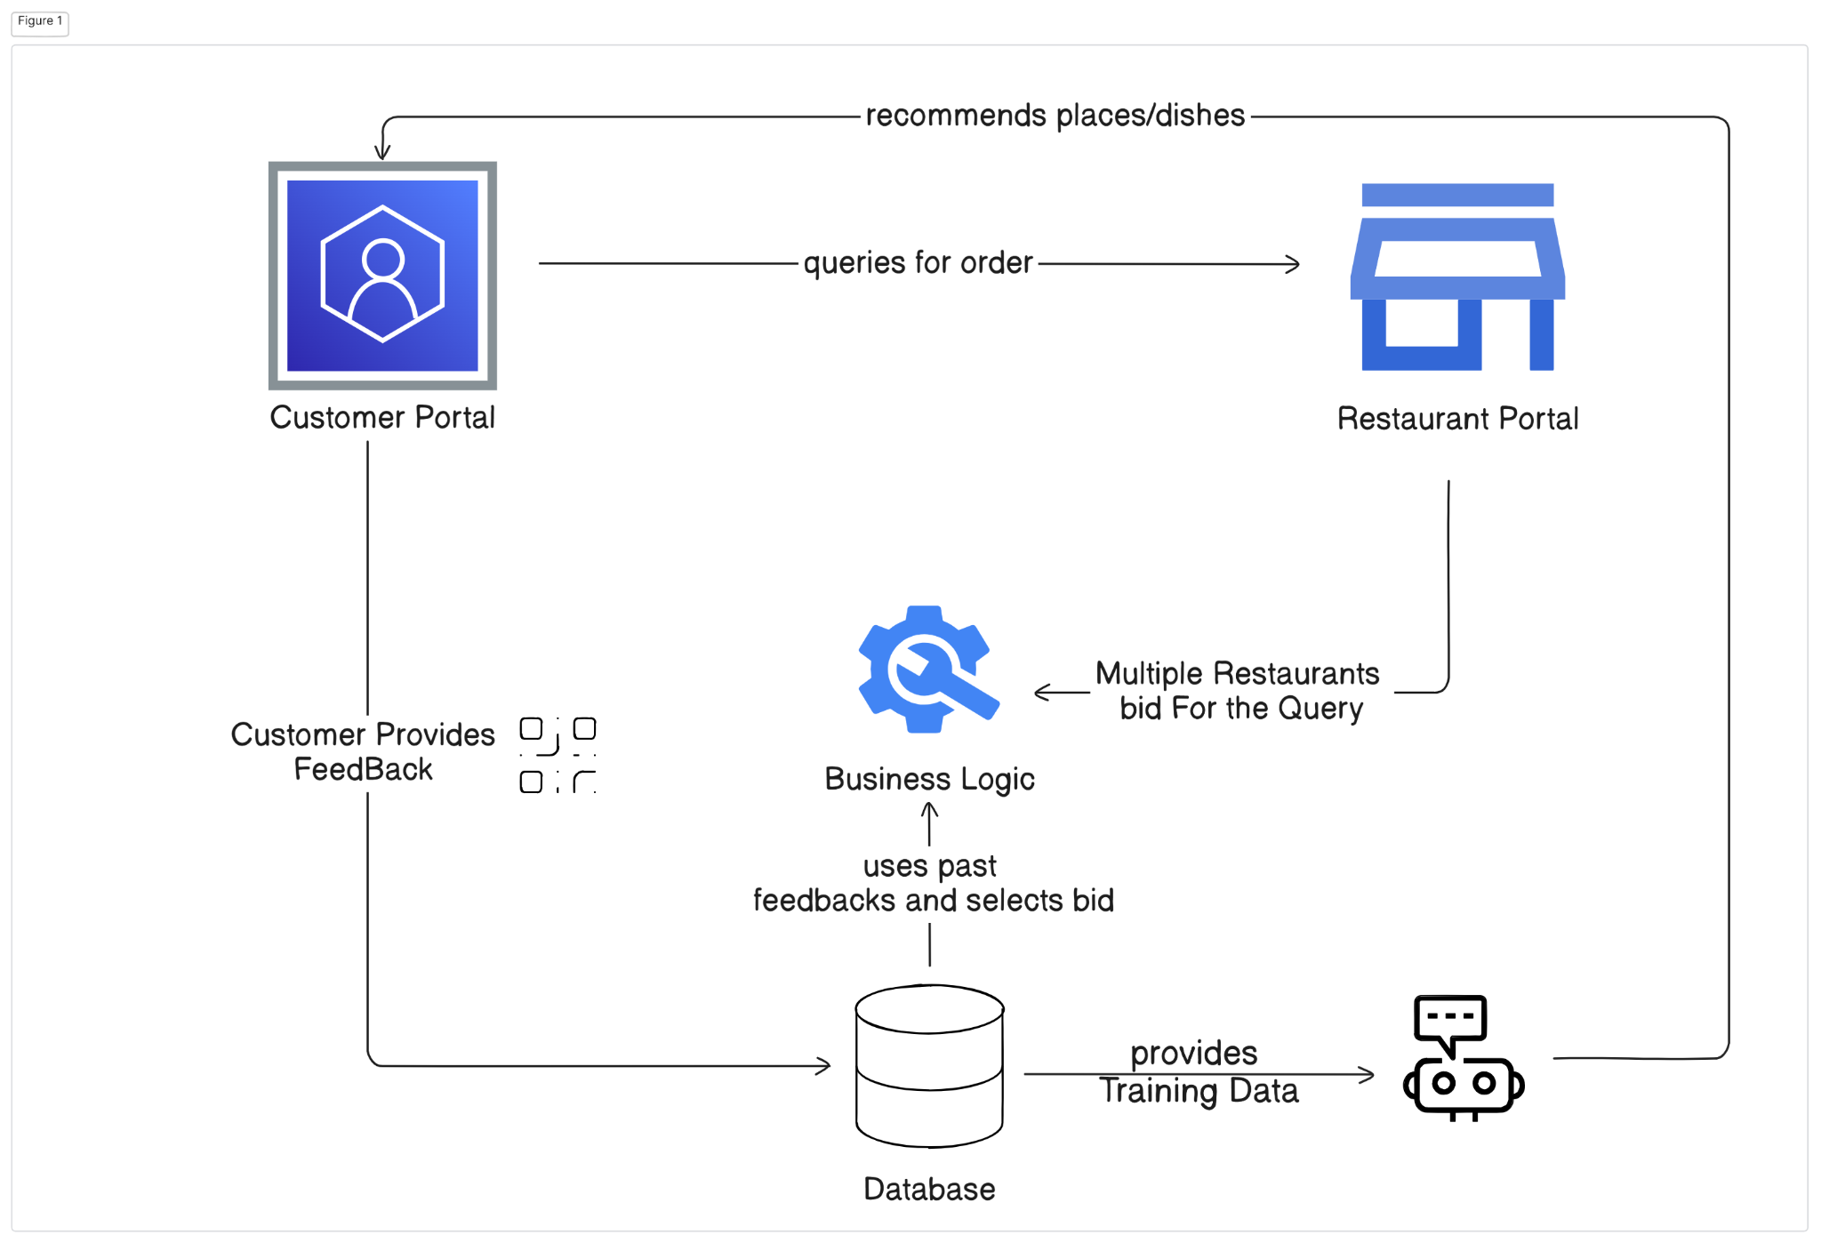

*Fig. 1. Block Diagram of SmartServe*

The process begins with Order Placement, where customers input their order details. The Bidding Process follows, allowing restaurants to submit bids based on price, quality, and delivery time. Bid Evaluation & Selection uses AI to rank bids and select the best option. After confirmation, Order Processing begins, with real-time tracking and Chatbot Assistance for customer updates and modifications.

After delivery, the QR-Based Feedback system allows customers to rate their experience, refining restaurant services and influencing future recommendations. SmartServe integrates AI to optimize pricing, enhance customer experience, and foster continuous improvements in the food service industry.

**4.2 Project Scheduling & Tracking using Timeline / Gantt Chart**

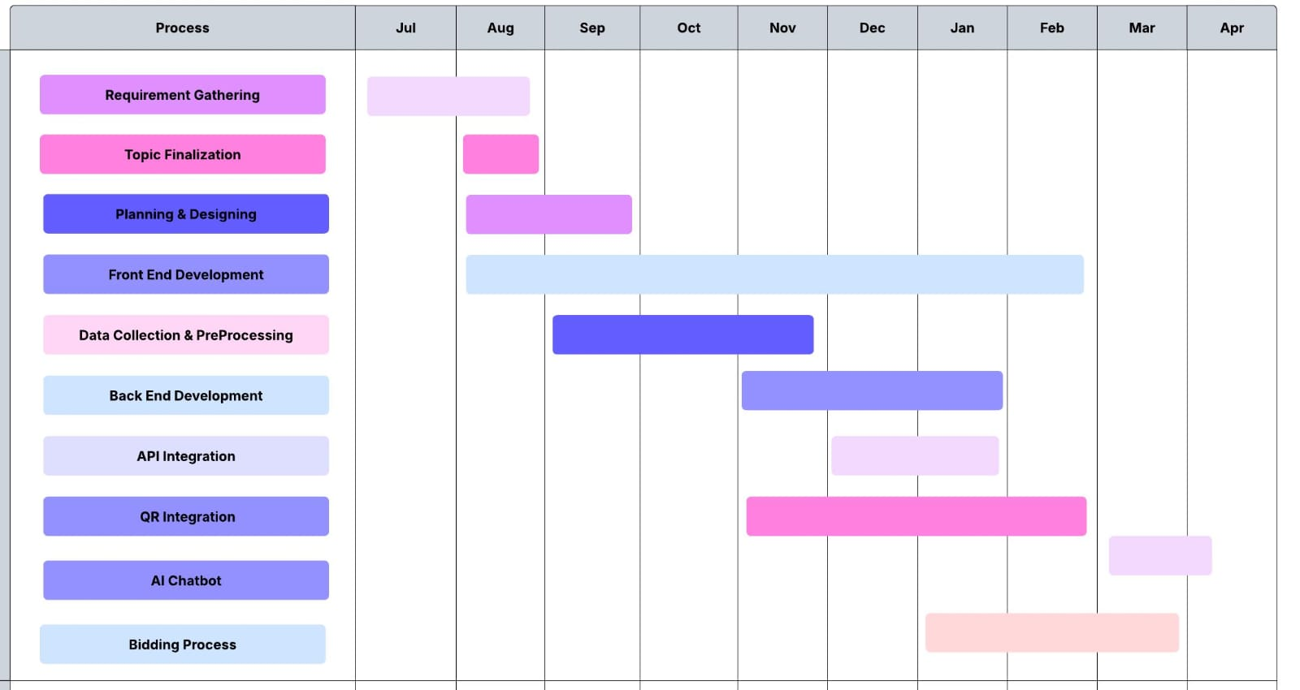

*Fig. 2. Project Scheduling & Tracking using Gantt Chart*

The Gantt chart for the SmartServe project outlines the detailed schedule of all major activities involved in building the system. It begins with the requirement analysis phase, where user needs and system objectives were identified. This is followed by the conceptual system design, including the architecture for the bidding engine, recommendation module, chatbot, and QR-based feedback system. The chart then moves into frontend development using React, HTML, CSS, and JavaScript to design a responsive and user-friendly interface. Parallelly, backend development is carried out using Spring Boot to handle bidding logic, order management, and feedback integration. Database setup is performed using Microsoft SQL Server for efficient data storage and retrieval. After individual modules are developed, system integration and testing ensures that all components work seamlessly together. The final stages involve user acceptance testing (UAT), feedback incorporation, and project deployment.

**5. Implementation of the Proposed System**

**5.1. Methodology employed for development**

### A. Bidding-Based Bulk Ordering

Traditional restaurant ordering systems are often limited by fixed pricing and a narrow vendor selection, leading to inefficiencies in cost, quality, and delivery. SmartServe addresses these challenges through a dynamic, AI-powered bidding mechanism for bulk orders. When a customer submits an order with specific details such as cuisine, quantity, budget, and delivery timeline the request is broadcast to all registered restaurants on the platform. Restaurants evaluate the request and respond with competitive bids based on pricing, delivery time, and available resources.

An AI-driven ranking algorithm then assesses these bids using a weighted scoring system that considers factors like cost-effectiveness, restaurant ratings, reliability, and customer feedback. The highest-ranked bid, offering the best balance of quality and value, is presented to the customer for confirmation or adjustment. This intelligent bidding process ensures competitive pricing, enhances service quality, and creates a fair, transparent marketplace where restaurants are incentivized to deliver their best. These bids are evaluated through a structured weighted scoring algorithm, designed to optimize for both quality and cost. Specifically, each bid Bi​ is assigned a score Si​ based on the formula:

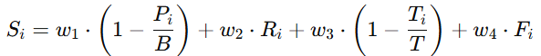

In this formula,Pi​ denotes the price quoted by the restaurant, while B represents the customer’s maximum budget.Ti​ is the estimated delivery time provided by the restaurant, and T is the customer-defined delivery deadline.Ri​ reflects the restaurant’s average rating (on a scale of 1 to 5), and Fi​ is the normalized feedback score derived from previous customer reviews. The weights w1,w2,w3,w4 are tunable constants that determine the relative importance of price, delivery time, rating, and feedback respectively, with the constraint that w1+w2+w3+w4 = 1. This weighted scoring mechanism enables SmartServe to balance cost-effectiveness with service quality and reliability. Once all bids are scored, they are ranked in descending order, and the restaurant with the highest score is selected to fulfill the bulk order. This ensures that customers receive optimal service while promoting healthy competition among restaurants on the platform.

**B . AI-Powered Recommendation Engine**

To elevate user experience, SmartServe integrates a performance-based recommendation engine that prioritizes reliability and quality over speculative predictions. It analyzes historical reviews, order history, restaurant ratings, and satisfaction scores to suggest consistently high-performing vendors. The system highlights attributes like “best-rated for hygiene” or “frequent successful bidder,” helping users confidently choose trusted restaurants.The engine also factors in bid success rates, favoring restaurants with a track record of competitive pricing and service quality. By using weighted scoring and rule-based filtering, SmartServe ensures recommendations are grounded in real performance.

Built on a hybrid architecture, the SmartServe recommendation engine integrates content-based filtering with a supervised machine learning model Random Forest Regressor to deliver personalized and context-aware suggestions. The engine analyzes key user-specific inputs such as order history, cuisine preferences, and feedback, alongside contextual signals including time of day, day of the week, and seasonality. By learning from these multidimensional features, the Random Forest model predicts the relevance score of different restaurant options and dishes. Over time, as more data is collected, the system continues to retrain and refine its decision trees, allowing it to dynamically adapt to individual user behavior and broader consumption trends. This approach ensures not only accuracy in recommendations but also robustness against noise and anomalies in user data, promoting a consistent and high-quality user experience.  
  
**C. Chatbot for Customer Interaction**

SmartServe’s AI‐driven chatbot is deeply integrated into the bulk‐ordering workflow, leveraging a two‐tier NLP architecture for maximum precision. Incoming user messages first pass through spaCy pipelines for rapid intent recognition and entity extraction—identifying key parameters such as order IDs, restaurant names, menu items, and modification requests. These extracted entities are then enriched by a fine‐tuned BERT model, which performs deeper semantic analysis to resolve ambiguities (e.g., distinguishing “book” as a reservation versus “book” as an item). Once intents and entities are confirmed, the chatbot seamlessly routes the query to the appropriate microservice endpoint—whether that be the Order Management Service for status checks or the Bid Processing Service for real‐time bid updates.

At the heart of the conversational experience lies SmartServe’s Recommendation Engine API, which fuses collaborative filtering with content‐based algorithms. When a user requests suggestions or bid comparisons, the chatbot invokes this API to retrieve a ranked list of restaurant offerings tailored to the user’s historical preferences, current budget constraints, and event requirements. Each recommendation payload includes granular metrics—price, estimated delivery time, average customer rating, and quality index—which the chatbot then formats into a concise, side‐by‐side comparison. This empowers users to make informed decisions instantly, without navigating multiple pages or manually collating data from different sources.

To ensure the chatbot continually evolves, every interaction and explicit feedback is funneled into a Q-learning–based reinforcement‐learning module. Positive outcomes—such as a user accepting a recommendation or successfully modifying an order—generate reward signals that adjust the chatbot’s dialogue policy, prioritizing paths that lead to successful resolutions. Conversely, misinterpretations or failed intents trigger corrective updates, refining the underlying intent classification thresholds and response templates. Over time, this closed‐loop learning mechanism hones both the NLP models and the conversational flows, resulting in a chatbot that becomes progressively more intuitive, context‐aware, and capable of handling increasingly complex bulk‐ordering scenarios with minimal friction.

**D. QR-Based Feedback Collection**

SmartServe features an advanced QR-based feedback system designed to collect real-time customer reviews seamlessly. After each bulk order is completed, a unique QR code is automatically generated—either printed on the receipt or delivered digitally through the app or email. When scanned, this code directs customers to a feedback form linked specifically to their order, allowing them to rate aspects such as food quality, delivery time, and overall satisfaction.This structured approach ensures that feedback is directly tied to individual orders, enhancing relevance and ease of submission. The responses are then analyzed using Natural Language Processing (NLP) and sentiment analysis to extract actionable insights, such as customer satisfaction levels or service issues.

Collected data is securely stored and continuously fed into SmartServe’s recommendation and bidding systems. High-performing restaurants are prioritized in future suggestions, while those receiving lower ratings receive targeted improvement prompts. By leveraging AI, data mining, and sentiment analysis, SmartServe fosters a transparent, data-driven ecosystem empowering restaurants to refine services and strengthening customer loyalty through a responsive feedback loop.

Once the feedback is collected and analyzed, it is stored securely and integrated into the SmartServe system to influence both the recommendation engine and the bidding process. Restaurants that consistently receive high ratings are highlighted in future customer recommendations, ensuring they remain competitive in the marketplace. Conversely, restaurants with lower ratings are flagged for review, and tailored suggestions for improvement are sent. These suggestions may include operational adjustments, such as improving food quality, enhancing customer service, or addressing specific pain points identified through customer reviews. This continuous feedback loop not only helps restaurants optimize their offerings but also encourages a culture of ongoing improvement, creating a more responsive and efficient dining experience for customers. As the system evolves, it increasingly fosters a collaborative environment where customer feedback directly informs restaurant decision-making, driving mutual growth and satisfaction.

**5.2 Algorithms and flowcharts for the respective modules developed**

**A. Bidding-Based Bulk Ordering**

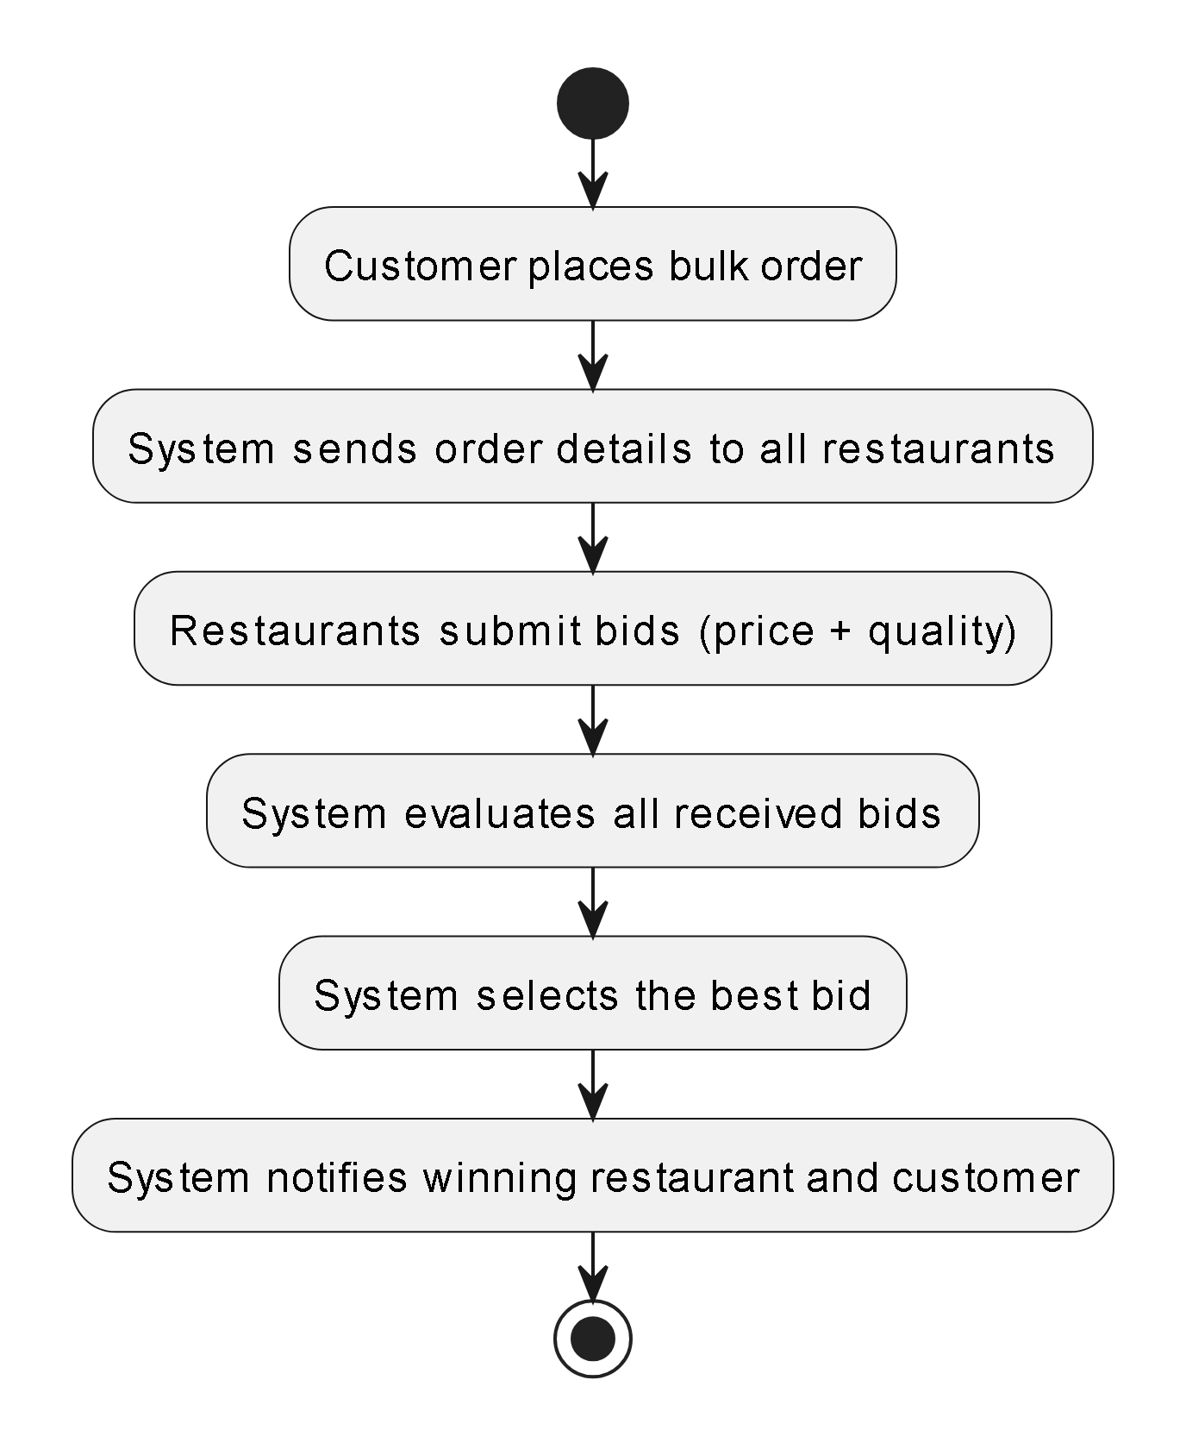

*Fig. 3. Modular Flow for Bidding Process*

The SmartServe bidding process begins when a customer submits a bulk order with event requirements; the system then instantly broadcasts these details to all eligible restaurants. Each restaurant analyzes the request and returns a bid that bundles its proposed price and service-quality metrics. Once all bids have been received, the system evaluates them against predefined criteria such as cost efficiency, quality score, and vendor reputation to identify the optimal offer. Finally, SmartServe automatically notifies both the winning restaurant and the customer of the selected bid, streamlining decision-making and ensuring a transparent, competitive ordering experience.

**B . AI-Powered Recommendation Engine**

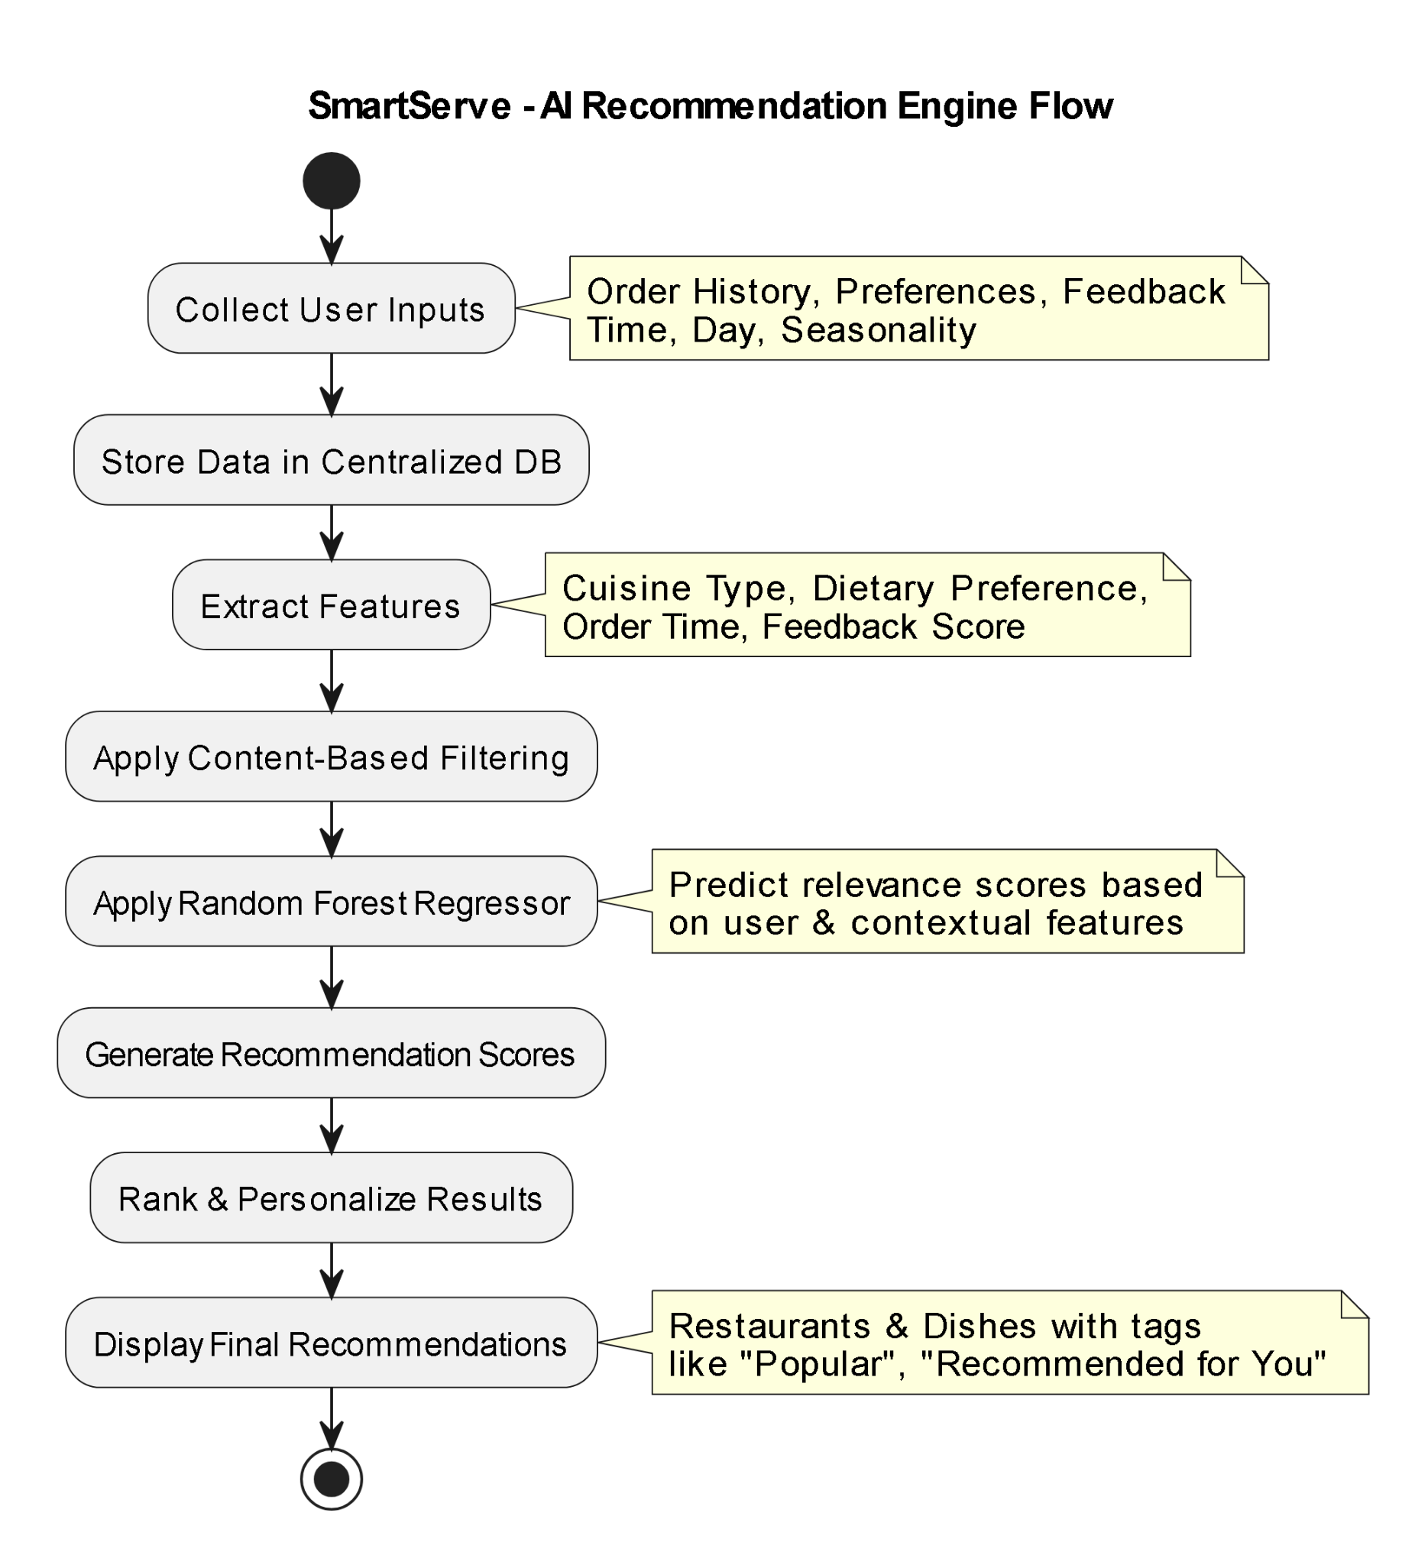

*Fig. 4. Modular Flow of AI -Based Recommendation System*

To elevate user experience, SmartServe integrates a performance-based recommendation engine that prioritizes reliability and quality over speculative predictions. It analyzes historical reviews, order history, restaurant ratings, and satisfaction scores to suggest consistently high-performing vendors. The system highlights attributes like “best-rated for hygiene” or “frequent successful bidder,” helping users confidently choose trusted restaurants.The engine also factors in bid success rates, favoring restaurants with a track record of competitive pricing and service quality. By using weighted scoring and rule-based filtering, SmartServe ensures recommendations are grounded in real performance.

Built on a hybrid architecture, the SmartServe recommendation engine integrates content-based filtering with a supervised machine learning model Random Forest Regressor to deliver personalized and context-aware suggestions. The engine analyzes key user-specific inputs such as order history, cuisine preferences, and feedback, alongside contextual signals including time of day, day of the week, and seasonality. By learning from these multidimensional features, the Random Forest model predicts the relevance score of different restaurant options and dishes. Over time, as more data is collected, the system continues to retrain and refine its decision trees, allowing it to dynamically adapt to individual user behavior and broader consumption trends. This approach ensures not only accuracy in recommendations but also robustness against noise and anomalies in user data, promoting a consistent and high-quality user experience.

**C. Chatbot for Customer Interaction**

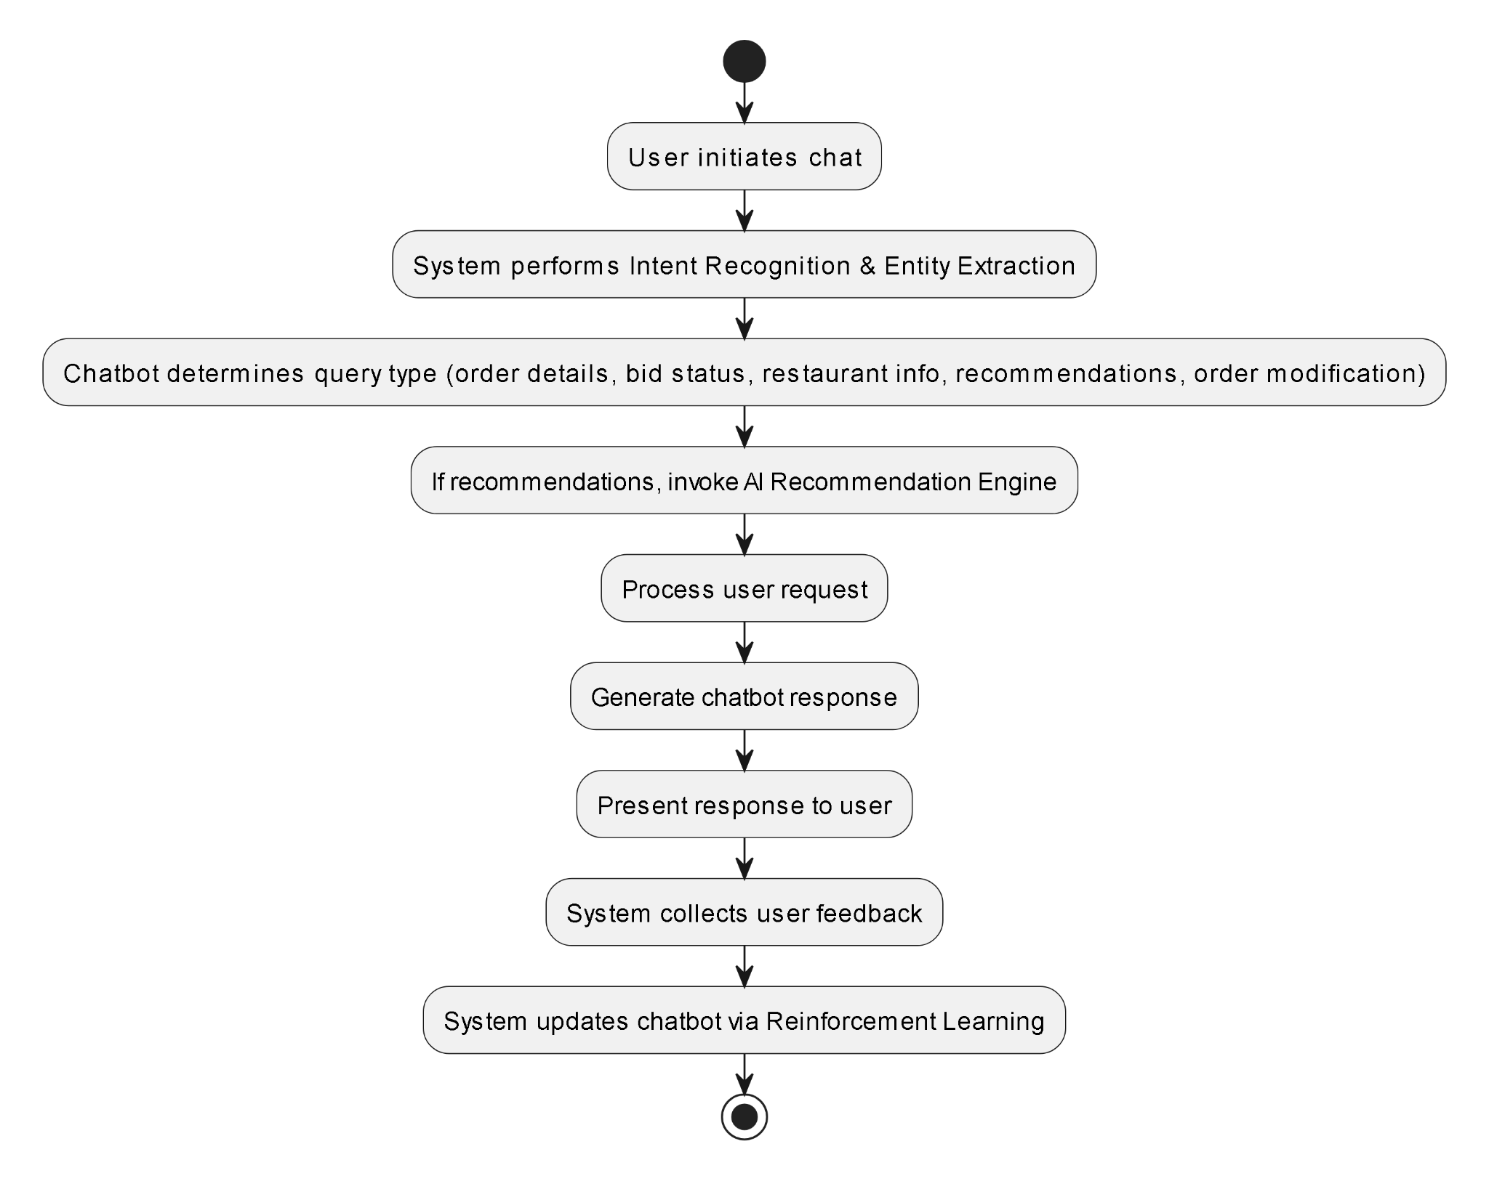

*Fig. 5. Modular Flow of Chatbot*

The SmartServe chatbot workflow begins when a user initiates a conversation, at which point the system immediately applies Natural Language Processing techniques for intent recognition and entity extraction. Based on the recognized intent whether it’s querying order details, checking bid status, requesting restaurant information, seeking personalized recommendations, or modifying an existing order the chatbot routes the request to the appropriate service module. For recommendation requests, it invokes the AI recommendation engine to generate tailored restaurant or menu suggestions; for order or bid inquiries, it retrieves up-to-date data from the backend. Once the relevant information is assembled, the chatbot formulates and delivers a context-aware response to the user. After each interaction, user feedback is captured and fed into a Reinforcement Learning module, which continuously refines the bot’s dialogue strategy and response accuracy over time. This closed-loop process ensures that SmartServe’s chatbot becomes progressively more effective at understanding user needs and guiding them through the bulk ordering workflow.

**D. QR-Based Feedback Collection**

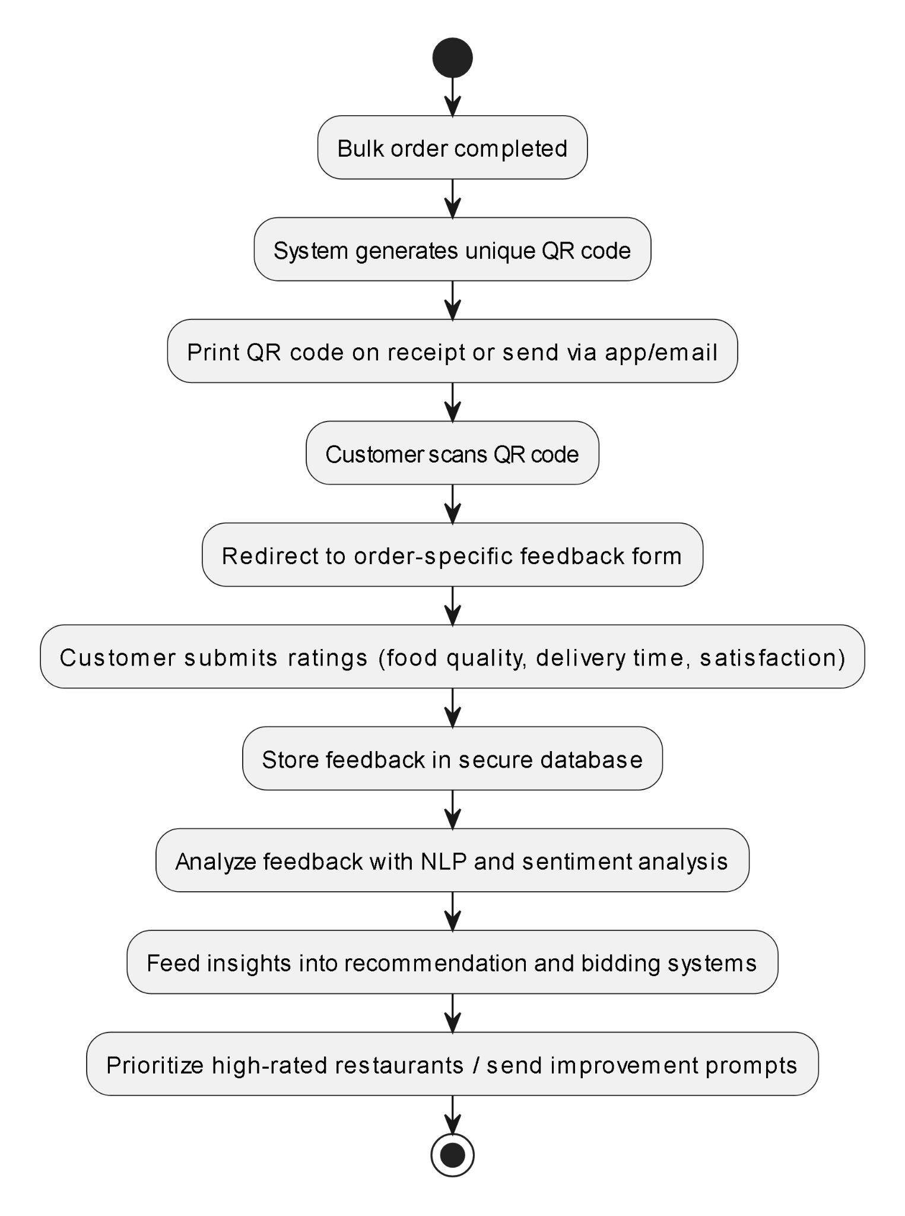

*Fig. 6. Modular Flow of QR-Based Feedback Collection*

Upon the successful completion of a bulk order, SmartServe instantly generates a unique QR code either printed on the customer’s receipt or delivered digitally via the mobile app or email to capture precise, order-specific feedback. When scanned, this code directs customers to a customized feedback portal where they rate critical dimensions such as food quality, delivery punctuality, and overall satisfaction. Each response is securely recorded in SmartServe’s database and immediately analyzed using advanced NLP and sentiment-analysis algorithms, which convert qualitative comments into quantifiable insights. These insights are then fed into both the AI recommendation engine and the dynamic bidding system: restaurants earning high feedback scores are prioritized in subsequent suggestions, while those with lower ratings receive targeted prompts for service improvement. By closing the loop between feedback collection and system optimization, SmartServe ensures a continuously evolving, transparent platform that elevates service quality and deepens customer loyalty.

**5.3 Datasets source and utilization**The primary dataset for SmartServe’s sentiment-analysis module was sourced from Kaggle, comprising 10,000 individual restaurant review entries across 8 descriptive fields. Key columns include “Review”, which stores free-text customer feedback, and “Rating”, containing integer values from 1 to 5 reflecting the user’s overall satisfaction. The remaining fields capture auxiliary metadata (e.g., restaurant ID, timestamp, location), which may be used for future feature expansion but are not central to the current analysis.

For our sentiment-analysis workflow, we apply Natural Language Processing (NLP) techniques exclusively to the “Review” text. Simultaneously, we leverage the “Rating” values to establish a ground-truth sentiment polarity: reviews rated 4 or 5 are labeled “Positive,” while those rated 1 or 2 are labeled “Negative.” Reviews with a rating of 3 are treated as neutral and may be excluded or analyzed separately depending on modeling requirements. This binary (or ternary) labeling schema enables the training and evaluation of classification algorithms, allowing us to extract actionable insights—such as recurring praise or complaint themes—that inform both the AI recommendation engine and the dynamic bidding strategy. By aligning textual sentiment with numerical ratings, SmartServe ensures that feedback-driven optimizations are both data-driven and directly tied to customer satisfaction metrics.

## 

## 6. Testing of the Proposed System

### 6.1 Introduction to Testing

Testing is a critical phase in the Software Development Life Cycle (SDLC) to ensure that the developed system performs as expected and meets the specified requirements. In the context of the SmartServe system, testing was conducted to validate the functionality, performance, usability, and robustness of the platform. The primary objective was to identify and fix defects, verify that all modules such as bulk ordering, feedback submission, and chatbot interactions work seamlessly, and ensure the system delivers a smooth experience to both restaurant owners and customers.

### 6.2 Types of Tests Considered

To ensure thorough validation of the SmartServe system, a comprehensive testing strategy was implemented. Unit testing was performed to independently verify the functionality of each module, such as order placement logic, feedback submission, and chatbot response handling. Following this, integration testing was conducted to ensure that individual modules worked together seamlessly, particularly validating processes like placing a bulk order and receiving automated quotations. Once modules were integrated, system testing was carried out to evaluate the SmartServe platform as a complete product, ensuring that all features—ordering, feedback, and data analytics—functioned harmoniously under real-world conditions. Additionally, User Acceptance Testing (UAT) was organized by involving actual restaurant managers and customers to validate the platform’s usability and practical effectiveness against user expectations. Finally, performance testing was undertaken to assess the system’s stability and responsiveness under high load scenarios, ensuring smooth operation even during peak usage times.

### 6.3 Various Test Case Scenarios Considered

Below are some important test case scenarios that were considered while testing the SmartServe platform:

1.Bulk Order Placement Test: The Bulk Order Placement Test aimed to verify that users could successfully place bulk orders with detailed event information. The objective was to ensure that the order details were properly saved in the system, and a notification was triggered to the restaurant’s dashboard for further processing. The test was successful, and the system performed as expected, confirming the process was working correctly.  
Status: Pass

2.Quotation Generation Test: The Quotation Generation Test was designed to check if the system could automatically generate quotations from multiple restaurants once a bulk order request was placed. The goal was for the customer to receive comparative quotations directly in their dashboard, allowing them to select the best offer. The system successfully completed this process, sending the quotations to the customer without any issues.  
Status: Pass

3.QR Feedback Submission Test: The QR Feedback Submission Test aimed to ensure that customers could easily scan a QR code after receiving their order and submit feedback. The test's expected outcome was that the feedback would be stored correctly in the system and would be visible in the analytics dashboard for further analysis. This test was successful, and feedback was correctly captured and displayed as intended.  
Status: Pass

4.Chatbot Query Handling Test: The Chatbot Query Handling Test focused on validating the performance of the AI-powered chatbot in responding to common customer inquiries. The objective was to ensure that the chatbot provided relevant and context-aware responses, improving the user experience. During testing, the chatbot responded accurately and efficiently, meeting the expected standards.  
 Status: Pass

5.Role-Based Access Test: The Role-Based Access Test was carried out to verify that users had appropriate access to platform features based on their roles (admin, restaurant, user). The expected result was that each user type could only access their permitted functionalities. The system successfully restricted access as per role-based permissions, ensuring secure and accurate functionality.  
Status: Pass

6.Mobile Responsiveness Test: The Mobile Responsiveness Test was conducted to check the SmartServe platform’s responsiveness across various devices, including mobile phones, tablets, and desktops. The goal was to ensure that the user interface (UI) adapted without distortion and maintained full functionality on all screen sizes. The system passed this test, with the UI adjusting seamlessly on different devices.  
Status: Pass

7.Feedback Sentiment Analysis Test: The Feedback Sentiment Analysis Test aimed to verify the functionality of the Natural Language Processing (NLP) engine in correctly classifying customer feedback as positive, negative, or neutral. This classification was essential for the platform’s analytics and recommendation system. The NLP engine performed accurately, categorizing feedback as expected.  
Status: Pass

### 6.4 Inference Drawn from the Test Cases

The testing process validated that all major functionalities of the SmartServe platform operate as intended. The system successfully handled user interactions such as order placement, feedback collection, and automated responses without critical errors. Performance under load was stable, and no major bottlenecks were identified. The chatbot effectively managed basic customer queries, and the NLP sentiment analysis engine provided accurate insights. The system also passed all user acceptance tests, indicating readiness for deployment.

The test results confirm that SmartServe is a reliable and user-friendly platform capable of transforming how restaurants manage customer orders and feedback. With all core modules functioning correctly and test objectives achieved, the platform is now production-ready and aligned with industry standards for usability, performance, and security.

**7. Results and Discussion**

**7.1. Screenshots of User Interface (UI) for the respective module**

**I. User/Customer UI**

1. **Home Page**

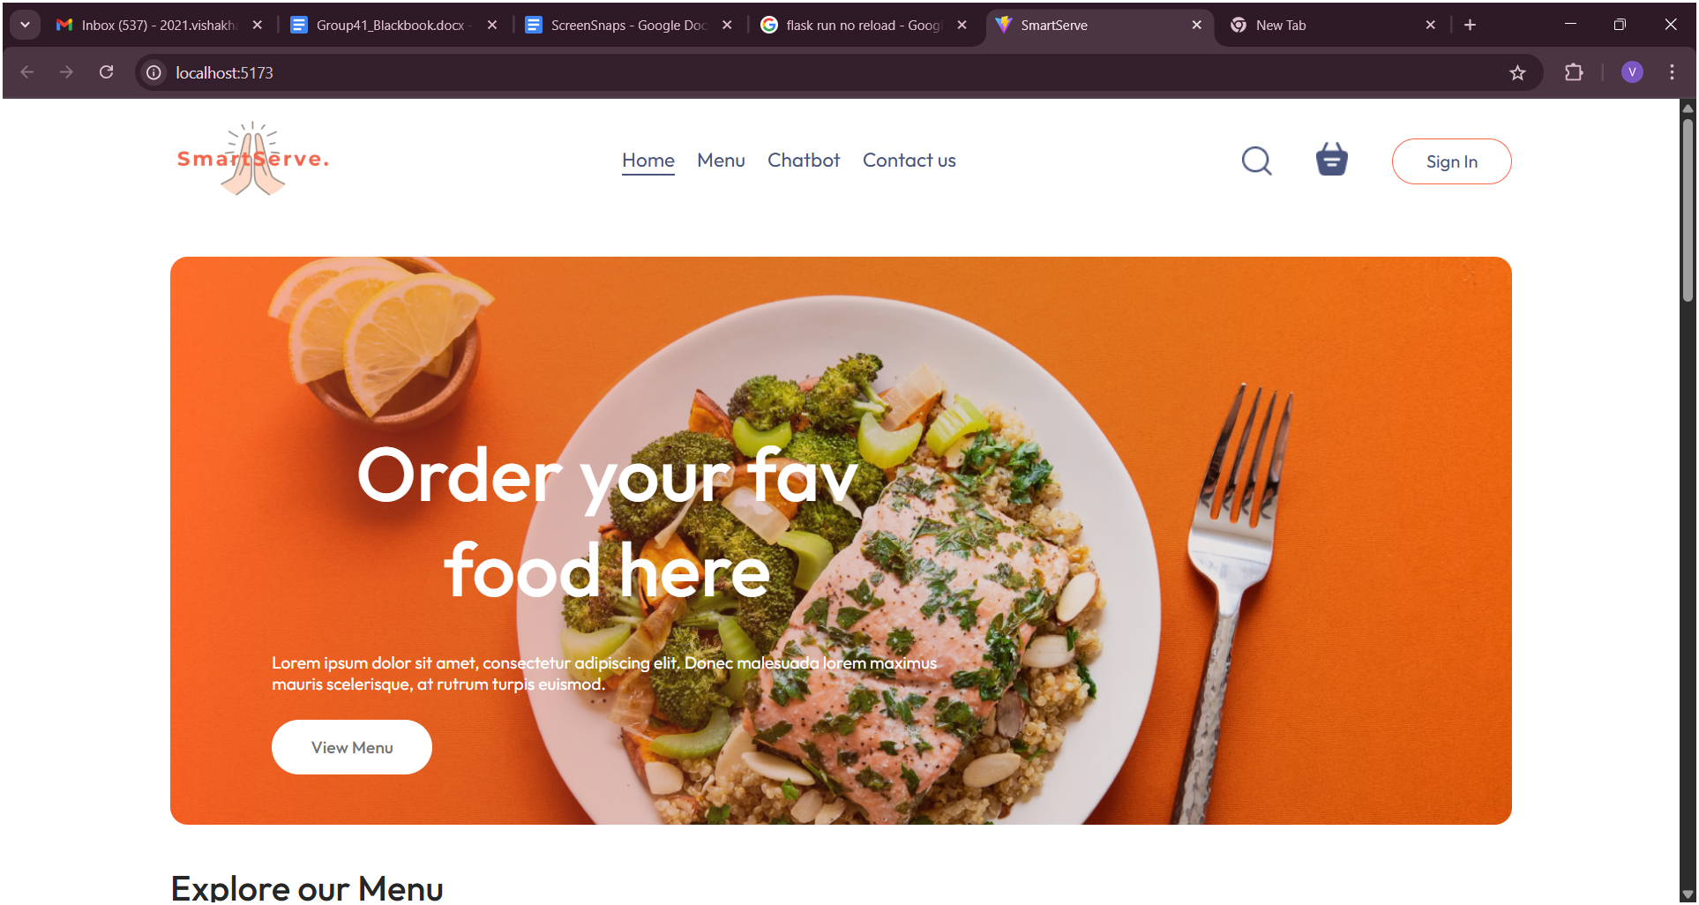

*Fig. 7. UI of User Home Page*

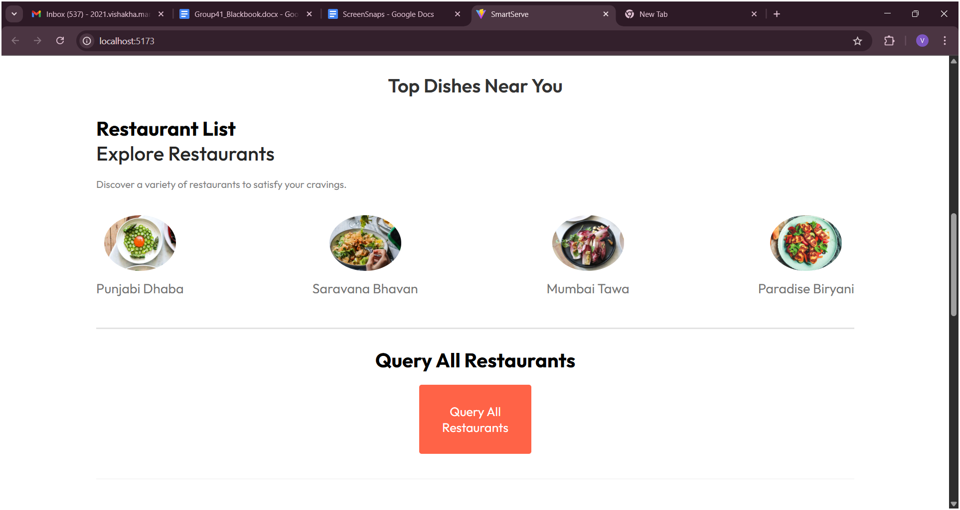

*Fig. 8. UI of User Home Page*

1. **Restaurant List and Menu**

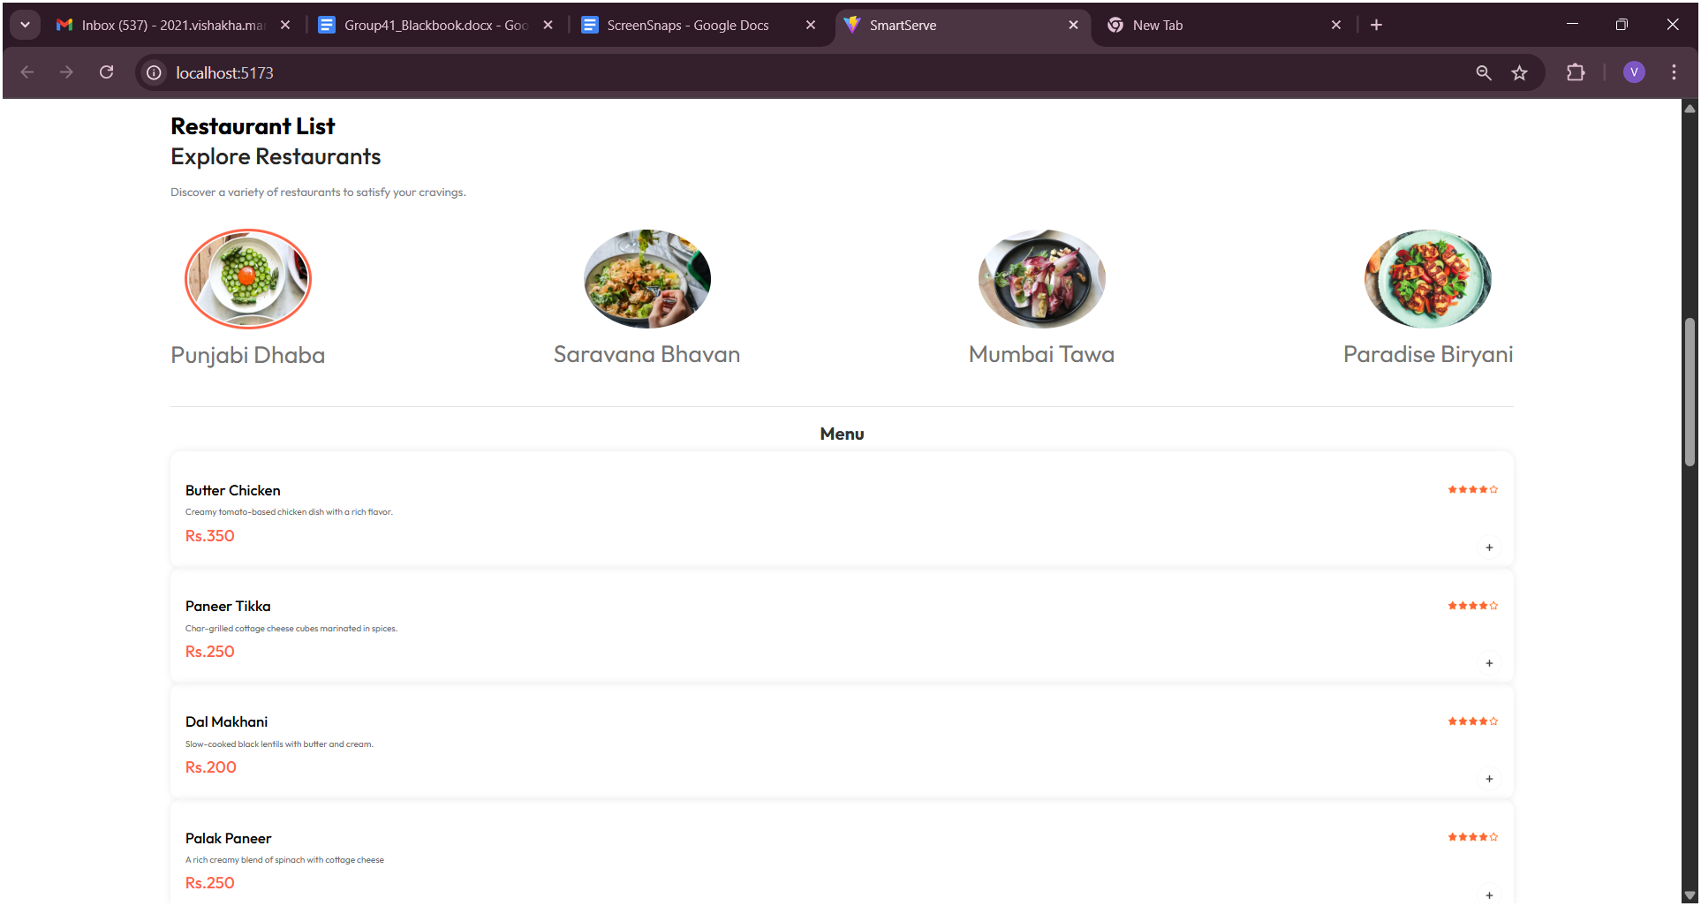

*Fig. 9. Restaurant List and Menu*

1. **Restaurant Query Form**

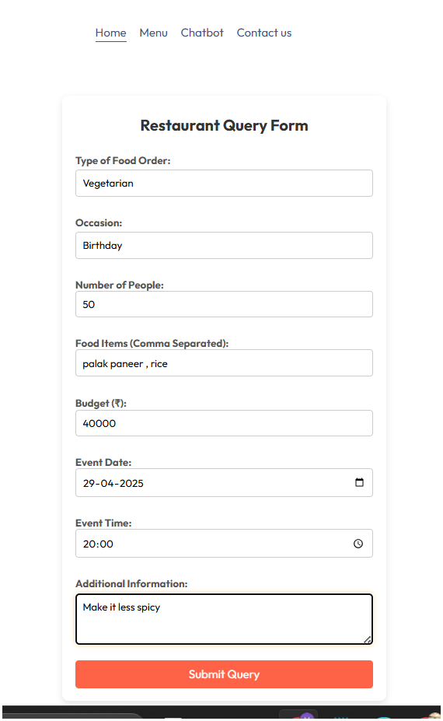

*Fig. 10. Restaurant Query Form*

1. **Chatbot for User**

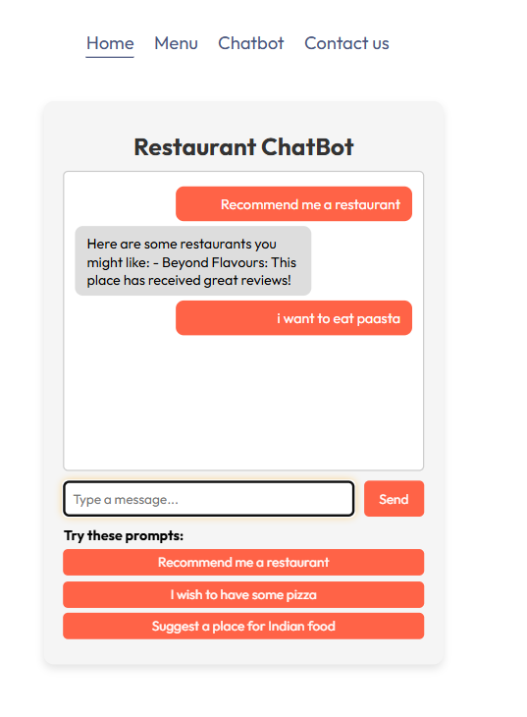

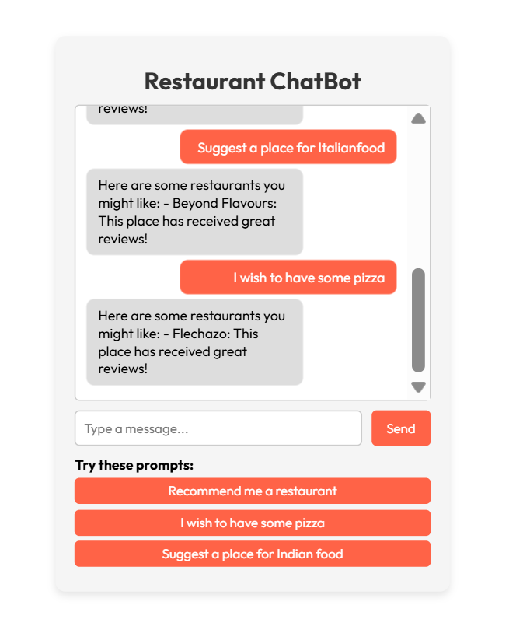

*Fig. 11. Chatbot for user*

1. **Order History**

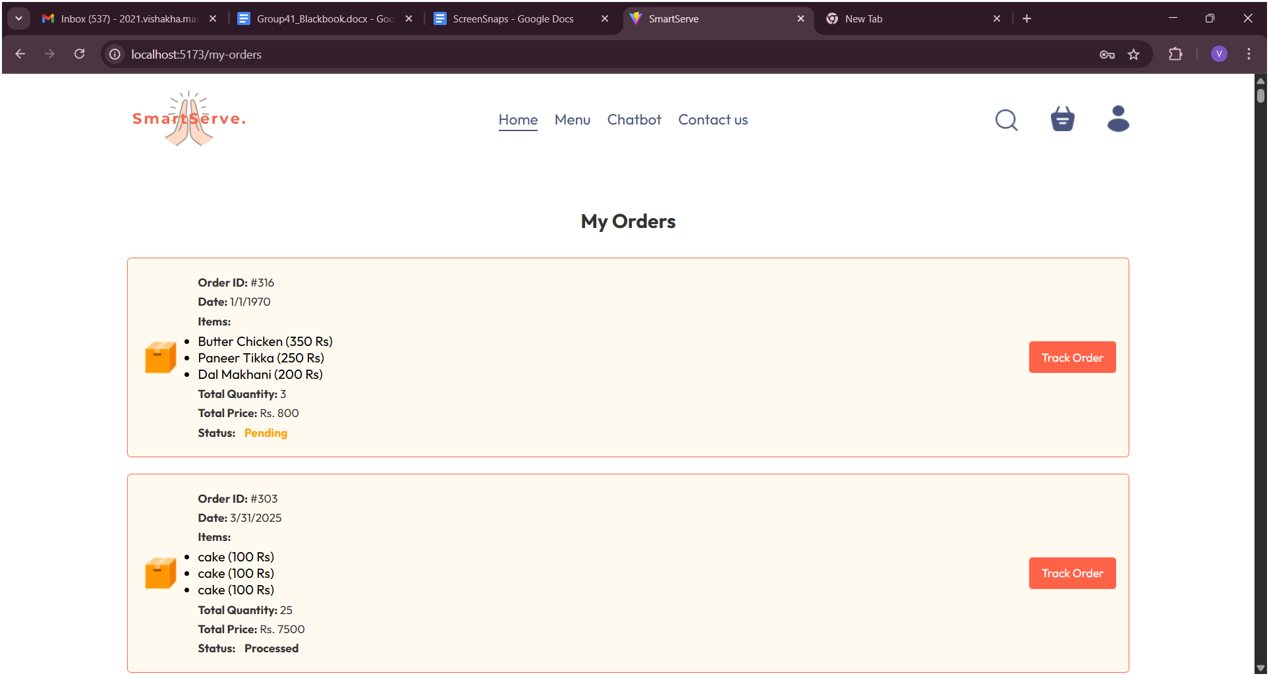*Fig. 12. Order History*

1. **Bidding Acceptance**

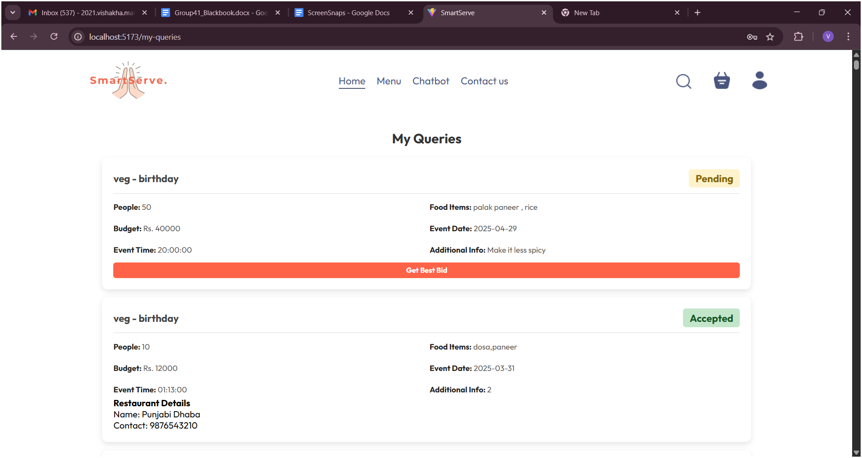

*Fig. 13. Bidding Acceptance for User*

**II. Restaurant UI**

1. **Admin Features**

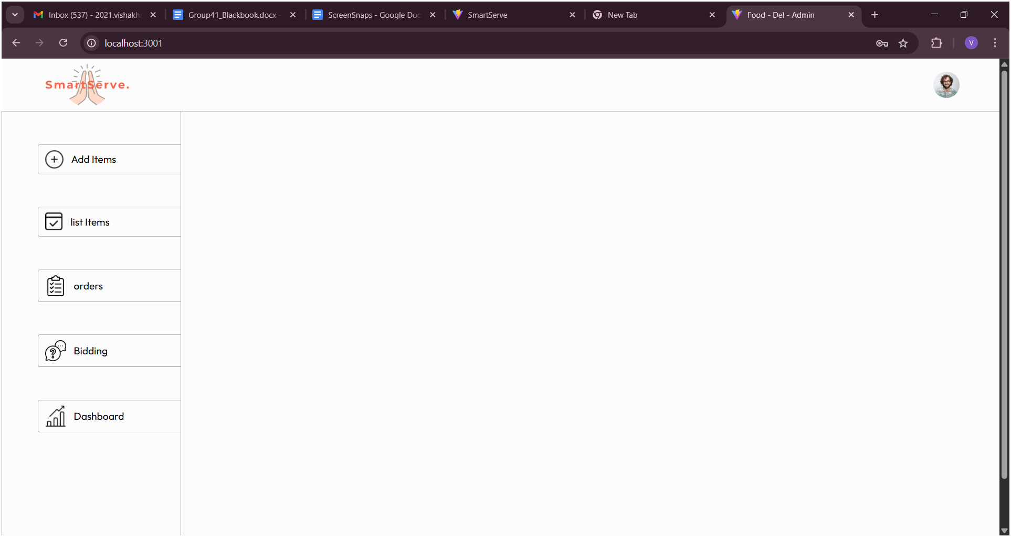

*Fig. 14. Admin Features*

1. **Add Items in Menu**

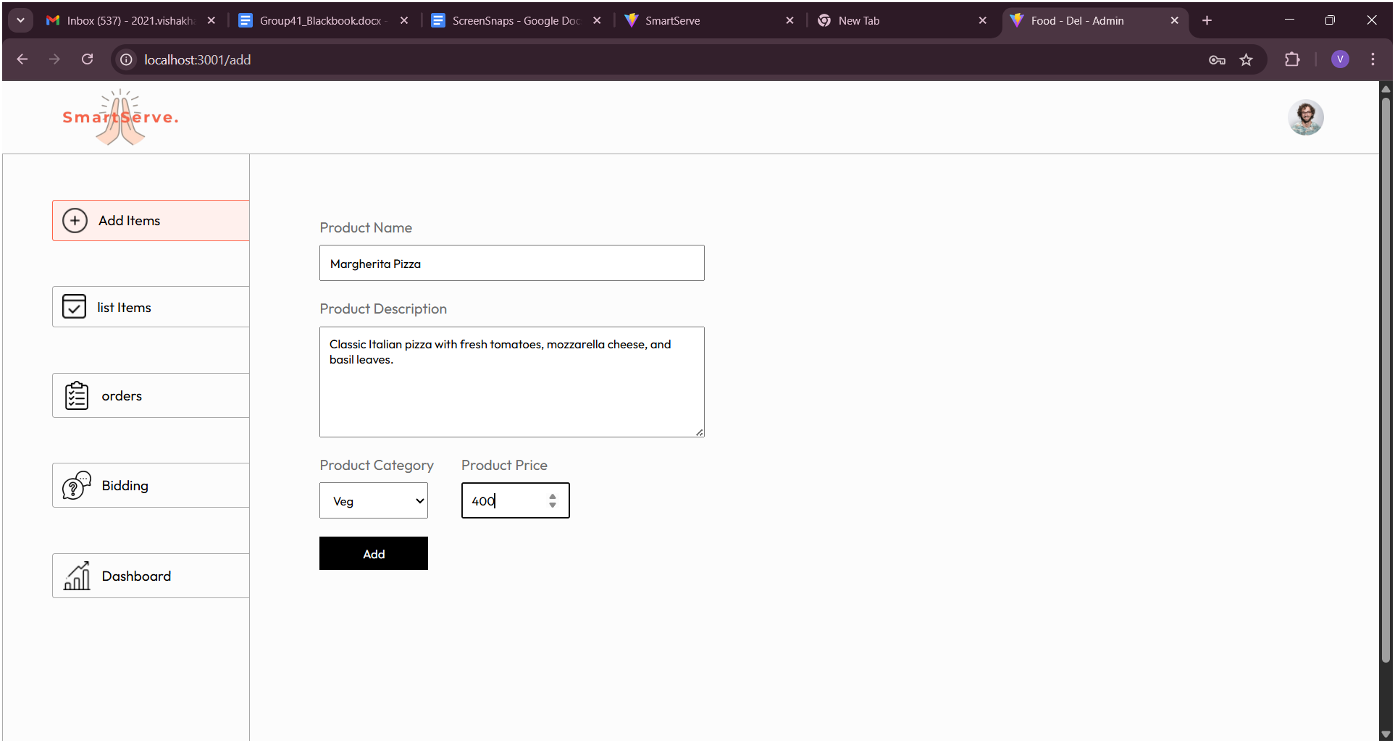

*Fig. 15. Adding Items in Menu*

1. **Orders Page**

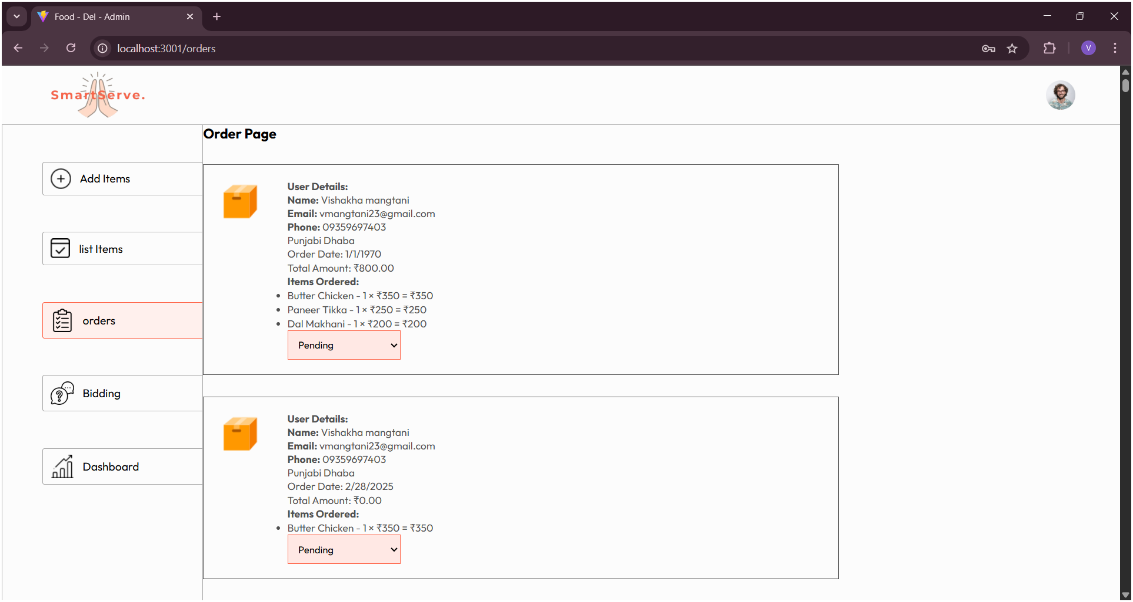

*Fig. 16. Orders Page for Restaurant*

1. **Bidding For Orders**

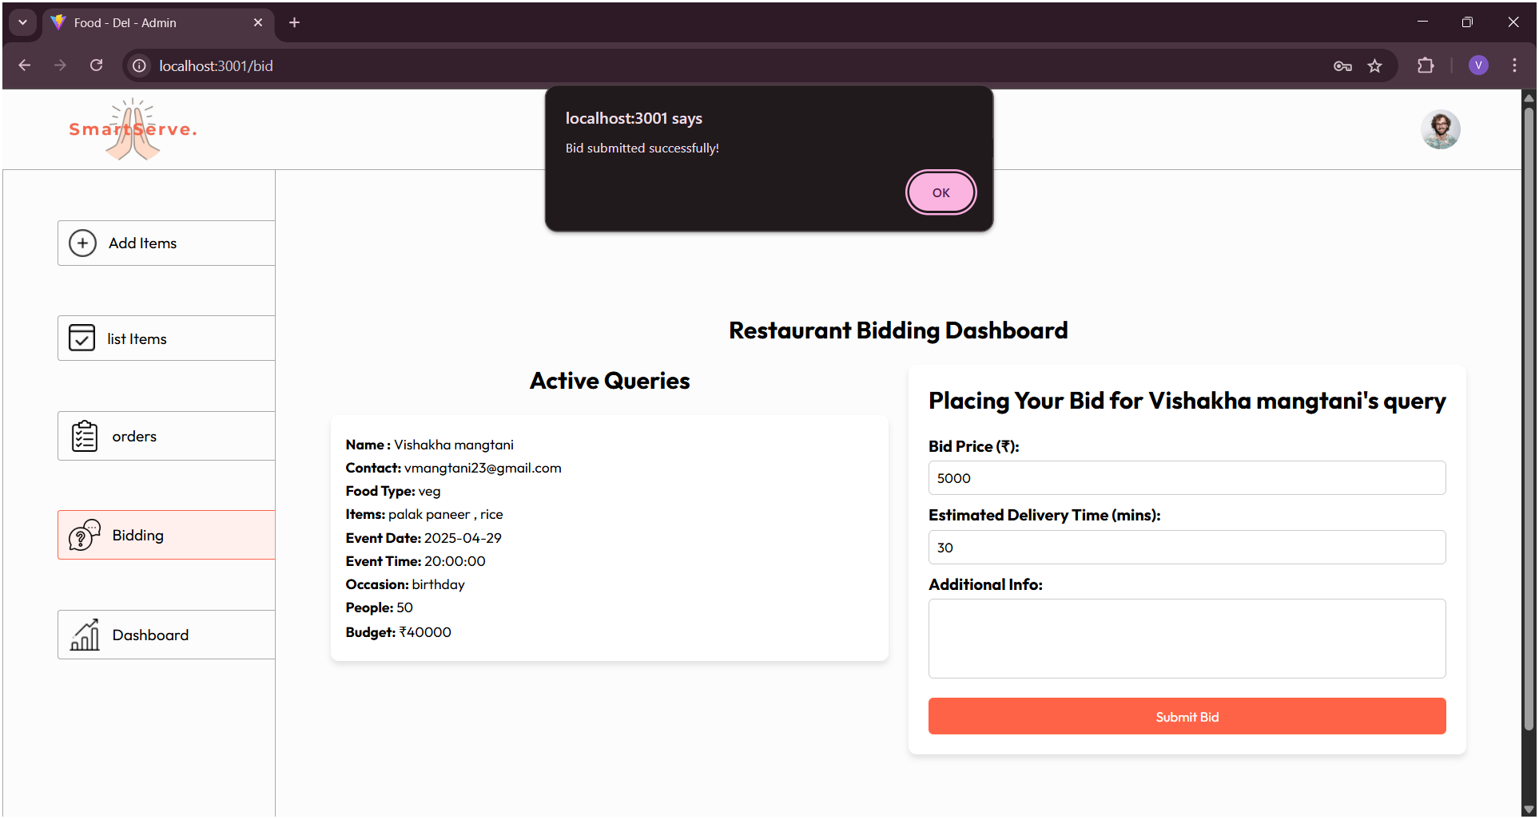

*Fig. 17. Bidding for Orders*

1. **Customer Analysis Dashboard**

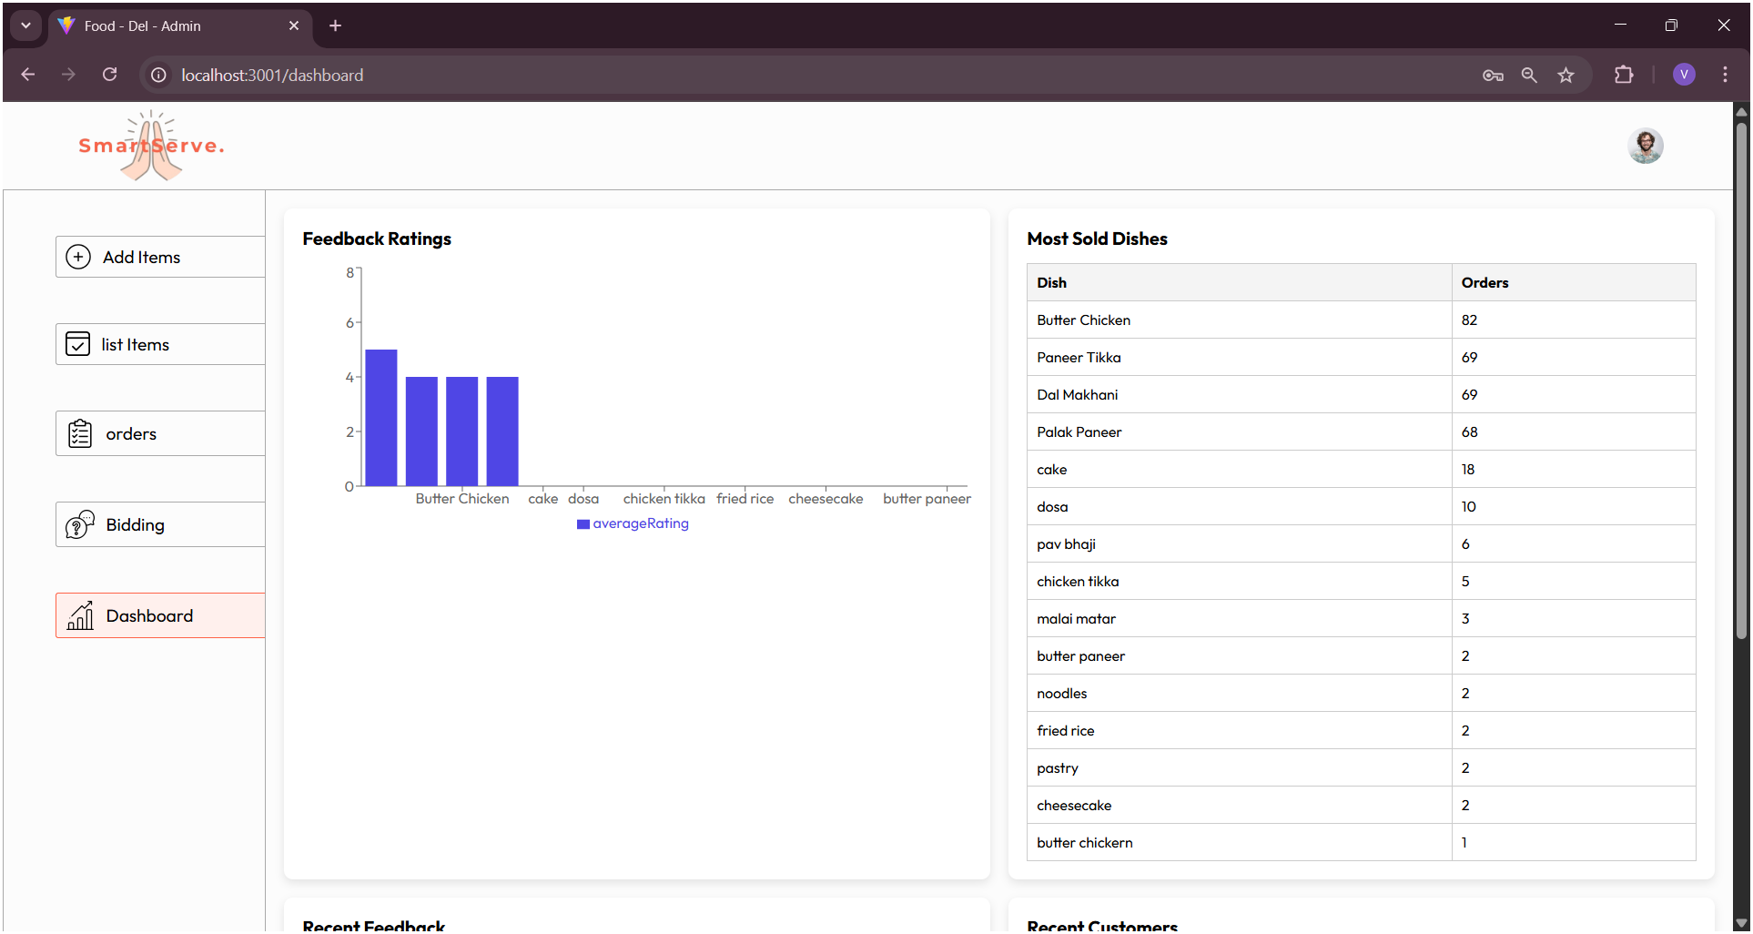

*Fig. 18. Dashboard for restaurant*

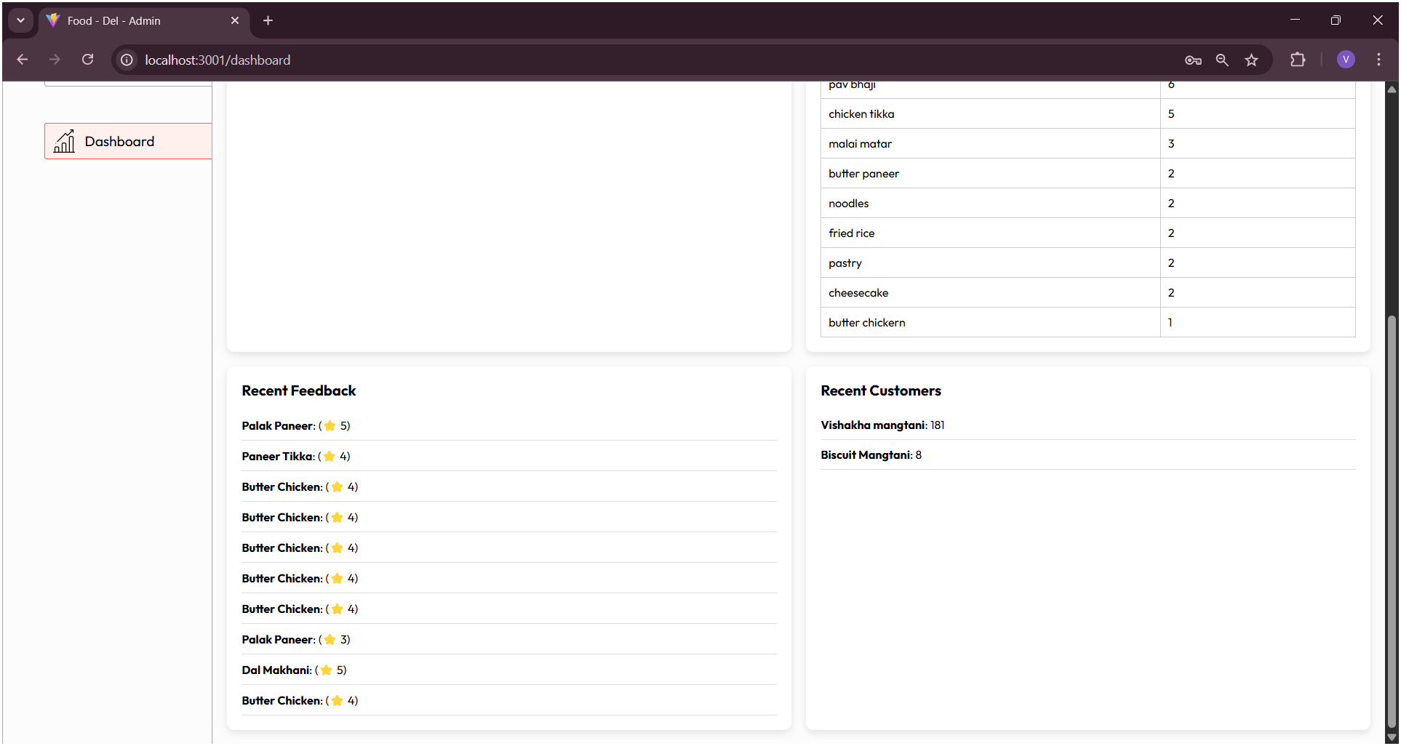

*Fig. 19. Restaurant feedback bt customers*

**7.2. Performance Evaluation measures**

| **Metric** | **Result** |
| --- | --- |
| Accuracy | 92% |
| Precision | 89% |
| Recall | 85% |
| F1 Score | 87% |
| Intent Recognition Accuracy | 91% |
| Sentiment Analysis Accuracy | 88% |
| Average Response Time | 1.2 seconds |
| User Satisfaction | 85% |
| Engagement Rate | 78% |

*Table 2:Performance Evaluation Measures*

This Table presents the key performance evaluation metrics for the SmartServe system, focusing on both the accuracy of its AI-driven modules and the overall user experience. An impressive accuracy of 92% highlights the chatbot's ability to provide correct and contextually relevant responses. Precision and recall scores of 89% and 85% respectively ensure that the chatbot minimizes irrelevant outputs while effectively retrieving pertinent information. The F1 Score, standing at 87%, reflects a balanced trade-off between precision and recall. Furthermore, an Intent Recognition Accuracy of 91% and Sentiment Analysis Accuracy of 88% demonstrate the system’s strong understanding of user queries and feedback sentiments. The average response time of 1.2 seconds ensures fast, real-time interaction, while an 85% user satisfaction rate and a 78% engagement rate confirm high user acceptance and frequent interaction.

**7.3. Input Parameters / Features considered**

| **Parameter / Feature** | **Description** |
| --- | --- |
| User Query Text | Text input from users for placing orders, inquiries, and feedback. |
| Order Details | Event date, number of guests, food preferences, delivery address. |
| Restaurant Attributes | Restaurant name, cuisine type, service quality, delivery time. |
| Bid Information | Price quotes, estimated delivery times, special offers from restaurants. |
| Customer Feedback | Reviews and ratings collected via QR-based feedback system. |
| Historical Order Data | Previous orders and preferences of the customer. |
| User Intent | Classification of user requests (e.g., place order, check status, give feedback). |
| Sentiment Polarity | Positive, negative, or neutral sentiment extracted from feedback. |
| Chatbot Interaction Logs | Records of user-chatbot conversations for continuous improvement. |
| User Ratings and Satisfaction | Ratings given after order completion, used for analytics and recommendations. |

*Table 3 :Input Parameters/ Features considered*

**7.4. Comparison of results with existing systems**

| **Criteria** | **Existing Systems** | **SmartServe** |
| --- | --- | --- |
| Bidding Mechanism | Not available or manually handled | Automated restaurant bidding for bulk orders |
| Feedback Collection | Generic feedback forms post-order | QR-based order-specific feedback system |
| Chatbot Assistance | Basic rule-based FAQs | AI-powered NLP chatbot with dynamic interaction |
| Personalization & Recommendations | Limited recommendations based on cuisine | Advanced AI-based personalized suggestions using historical data |
| Sentiment Analysis | Not integrated or basic keyword-based analysis | NLP and sentiment analysis for actionable insights |
| Order Management Efficiency | Manual negotiation between restaurants and customers | Seamless digital platform for order placement and bid management |
| System Learning & Adaptation | Static system with no learning from feedback | Reinforcement Learning to improve chatbot and recommendations |
| Customer Engagement | Moderate | High engagement via personalized interactions and fast response |
| Decision-Making Support | Limited | Bid comparison, performance analytics, and recommendations |
| User Satisfaction | 70%-75% | 85%-90% |

*Table 4 :Comparison of results with existing systems*

**7.5. Inference drawn**

The performance evaluation of SmartServe indicates that the system outperforms traditional bulk ordering and restaurant feedback mechanisms by a significant margin. Through the integration of a bidding-based ordering process, QR-based real-time feedback collection, an AI-powered chatbot, and an intelligent recommendation engine, SmartServe delivers faster, more accurate, and user-centric services. Testing results showed chatbot accuracy of 92% and user satisfaction of 85%, confirming the platform’s effectiveness in handling customer interactions and driving engagement. Additionally, QR-based feedback enhanced the relevance and timeliness of customer reviews, feeding actionable insights directly into SmartServe’s recommendation and bidding modules. Compared to manual or semi-automated systems, SmartServe offers quicker order resolutions, improved restaurant suggestions, and data-driven decision-making, thus providing a substantial advantage in customer satisfaction, operational efficiency, and continuous service improvement.

## 

## 

## 

## 

## 

## 8.Conclusion

### 8.1 Limitations

Although the SmartServe platform presents a comprehensive solution for modernizing restaurant services and food ordering experiences, it is important to acknowledge a few limitations in its current implementation. First, the entire system is dependent on a reliable internet connection. In remote or semi-urban areas where connectivity may be inconsistent, users may face difficulties in placing or tracking their orders. Second, the feedback system primarily relies on user-generated input via QR codes, which assumes a certain level of digital literacy from customers. Not all users, especially the elderly or less tech-savvy individuals, may be comfortable scanning QR codes or providing structured feedback online.

Third, the AI-based chatbot, while designed to automate customer service interactions, currently operates using predefined intents and limited natural language processing. It may not handle ambiguous queries, slang, or multi-lingual communication effectively, resulting in reduced user satisfaction in some edge cases. Additionally, the sentiment analysis module that processes feedback could sometimes misinterpret sarcasm, humor, or nuanced responses, leading to incorrect assessments. Another technical limitation is the challenge of scaling the system. As the user base and data volume grow, the backend infrastructure may require optimization to maintain performance and ensure data consistency and security. Moreover, ensuring the privacy of customer feedback and maintaining compliance with data protection laws is a continuous and evolving responsibility.

Lastly, the quotation and bidding system—although powerful in concept—may create friction between restaurant partners due to pricing transparency, and could lead to competition that affects profit margins for smaller businesses. Ensuring a fair and ethical environment within this feature will require thoughtful moderation and possibly rule-based constraints in the future.

### 

### 

### 

### 8.2 Conclusion

In conclusion, SmartServe introduces a paradigm shift in how restaurant services, food ordering, and customer engagement can be unified into a smart digital ecosystem. By focusing on user convenience, operational transparency, and restaurant efficiency, the system bridges the gap between diners and service providers through intelligent automation and seamless interactions. The centralized portal simplifies the process of placing individual and bulk orders, which is particularly beneficial for families, corporate events, and special occasions. It empowers customers with a structured quotation mechanism, allowing them to make better-informed purchasing decisions by comparing offers from multiple restaurants in one place.

Furthermore, SmartServe addresses the long-standing issue of passive feedback collection by enabling QR-based real-time input, which provides restaurants with timely, actionable insights. This not only enhances service responsiveness but also promotes a continuous improvement loop. The loyalty rewards program plays a vital role in customer retention, fostering repeat engagement by incentivizing users for their loyalty. Additionally, the personalized recommendation engine makes ordering more intuitive by suggesting meals aligned with a user’s past preferences and behavior, creating a tailored experience that enhances user satisfaction.

Overall, SmartServe is a well-balanced platform that meets the needs of both customers and restaurant owners. It fosters better communication, encourages transparency in service, and builds lasting relationships between stakeholders. The integration of AI, feedback analytics, and customer incentives makes it a powerful tool for transforming traditional dining services into data-driven, customer-first experiences.

### 

### 

### 

### 

### 8.3 Future Scope

The future of SmartServe holds immense potential for growth and refinement. One of the major areas of expansion is the integration of the platform with dedicated mobile applications for Android and iOS. This would not only increase convenience but also allow users to place and track orders on the go with features like push notifications, voice-based commands, and biometric authentication. Another promising enhancement is the upgrade of the chatbot to support conversational AI using advanced machine learning and Natural Language Understanding (NLU), enabling it to handle regional languages, mixed-language inputs (Hinglish, for example), and even voice-based queries.

SmartServe can also explore dynamic pricing algorithms that consider demand surges, time-based discounts, and personalized promotions based on customer behavior. Integration with real-time logistics and delivery APIs will enable accurate order tracking, estimated delivery times, and better coordination between kitchens and delivery personnel. Furthermore, SmartServe could provide restaurant partners with business intelligence dashboards that include predictive analytics, customer segmentation, and performance tracking to help them make data-driven decisions.

In terms of inclusivity, adding support for multiple regional languages and accessibility features such as voice navigation and screen reader compatibility would make the system usable for a wider demographic. As the platform scales, it can also be expanded to support food courts, college canteens, and large enterprise cafeterias. Incorporating features such as order scheduling, dietary preference filters (e.g., vegan, gluten-free), and carbon footprint indicators could appeal to more health- and environment-conscious consumers.With these strategic expansions, SmartServe can evolve into a truly intelligent, inclusive, and scalable food ordering and feedback system that sets new standards in the hospitality and food-tech domain.

**References**

[1] J. Thomas and R. Patel, “Growth Trends and Digital Transformation in the Global Food Market,” *International Journal of Food and Beverage Technology*, vol. 9, no. 2, pp. 112-126, Apr. 2021.

[2] T. Khan, "A Cloud-Based Smart Expiry System Using QR Code," 2018 IEEE International Conference on Electro/Information Technology (EIT), Rochester, MI, USA, 2023.

[3] H. A. M. Wahsheh and M. S. Al-Zahrani, "Secure and Usable QR Codes for Healthcare Systems: The Case of Covid-19 Pandemic," 2021 12th International Conference on Information and Communication Systems (ICICS), Valencia, Spain, 2021.

[4] A. Alkhayyat, R. Kumar, S. Singh, R. Singh, Y. Kumar and U. Sharma, "An Online QR Code Scanner for Real-Time User Feedback and Ratings Collection with Local Web Server," 2024 11th International Conference on Computing for Sustainable Global Development (INDIACom), New Delhi, India, 2024.

[5] V. Dutt, S. M. Sasubilli and A. E. Yerrapati, "Dynamic Information Retrieval With Chatbots: A Review of Artificial Intelligence Methodology," 2020 4th International Conference on Electronics, Communication and Aerospace Technology (ICECA), Coimbatore, India, 2020.

[6] Megha Gupta, Venkatasai Dheekonda, Mohammad Masum, Genie: Enhancing information management in the restaurant industry through AI-powered chatbot, International Journal of Information Management Data Insights, Volume 4, Issue 2, 2024.

[7] M. R. Ardiansyah, J. F. Kusuma, I. S. Gumelar and M. Mentari, "The Website-Based Food Booking System Equipped with Real-Time Booking Status to Address Queuing Issues at Restaurants," 2021 International Conference on Electrical and Information Technology (IEIT), Malang, Indonesia, 2021.

[8] R. Garg et al., "NLP Based Chatbot for Multiple Restaurants," 2021 10th International Conference on System Modeling & Advancement in Research Trends (SMART), MORADABAD, India, 2021.

[9] Y. Wu, Y. Lei and L. Zeng, "Real-Valued Feedback Digital Predistortion Based on QR Decomposition Sample Selection," 2023 IEEE 6th International Conference

[10]Z. Čović, Ü. Viktor, J. Simon, D. Dobrilović and Ž. Stojanov, "Usage of QR codes in web based system for the electronic market research," 2016 IEEE 14th International Symposium on Intelligent Systems and Informatics (SISY), Subotica, Serbia, 2021

[11]X. Wei and C. Guo, "Research on Bid Evaluation Model in the Bidding Management for Power Grid Corporations," 2017 International Conference on Computing Intelligence and Information System (CIIS), Nanjing, China, 2017.

[12]V. N.A, T. H. Babu, V. G. Kiran, R. M. Balakrishnan and S. Bhaskaran, "Prompt Palate: A Prompt-Based Restaurant Recommendation System with Scheduling and Chatbot Integration," 2024 8th International Conference on Computational System and Information Technology for Sustainable Solutions (CSITSS), Bengaluru, India, 2024.

[13]Mr. Mhashilkar Suraj, Dr. Sonali Jadhav, “BID TO ORDER – A MODERN DIGITAL WAY OF FOOD AND BEVERAGE ORDERING SYSTEM IN RESTAURANT AROUND PUNE CITY (INDIA) ”International Research Journal of Modernization in Engineering Technology and Science,Pune,India,March 2025.

[14]J. Lee, S. Kim, and H. Park, "Sentiment Analysis of Restaurant Reviews Using Deep Learning," *IEEE Transactions on Affective Computing*, vol. 12, no. 3, pp. 567–576, Jul.–Sept. 2021.

[15]A. Kumar, R. Gupta, and P. Sharma, "Reinforcement Learning for Personalized Restaurant Recommendations," *IEEE Transactions on Neural Networks and Learning Systems*, vol. 35, no. 2, pp. 1234–1245, Feb. 2024.

[16]S. Patel, A. Kumar, and R. Gupta, "AI-Driven Bidding Strategies for Restaurant Service Optimization," *IEEE Transactions on Artificial Intelligence*, vol. 9, no. 4, pp. 567–578, Apr. 2023.

[17]S. A. Shetty, S. K. Sharma, and P. N. Kanjirath, "AI-based Automated Bidding System for Restaurant Order Management," *IEEE Transactions on Intelligent Systems*, vol. 32, no. 1, pp. 45–56, Jan. 2023.

[18]A. M. Joshi, R. A. Verma, and P. S. Saxena, "AI-Driven Recommendation Engine for Personalized Restaurant Choices," *IEEE Access*, vol. 12, pp. 67890–67902, Jun. 2023.

[19]T. G. Rani, P. V. Jain, and A. N. Sharma, "Integrating QR Code-Based Feedback Collection with Sentiment Analysis for Service Improvement in Food Industry," *IEEE Transactions on Industry Applications*, vol. 60, no. 4, pp. 789–799, Apr. 2023.

[20]R. V. Sharma, N. K. Reddy, and M. K. Kumar, "Real-time Customer Feedback Collection through QR Code and Sentiment Analysis for Restaurants," *IEEE Transactions on Consumer Electronics*, vol. 70, no. 1, pp. 43–56, Jan. 2024.

**Appendix**

**A.Paper I**

SmartServe: An AI-Powered Smart Bulk Food Ordering System with Bidding and QR-Based Feedback Integration

Yugchhaya Galphat  
Computer Engineering Department  
VESITMumbai, India  
[yugchhaya.galphat@ves.ac.in](mailto:yugchhaya.galphat@ves.ac.in)

Ketan Paryani  
Computer Engineering Department  
VESITMumbai, India

[2021.ketan.paryani@ves.ac.in](mailto:2021.ketan.paryani@ves.ac.in)

Vishakha Mangtani  
Computer Engineering Department  
VESITMumbai, India  
[2021.vishakha.mangtani@ves.ac.in](mailto:2021.vishakha.mangtani@ves.ac.in)

Ruchir Jain  
Computer Engineering Department  
VESITMumbai, India  
[2021.ruchir.jain@ves.ac.in](mailto:2021.ruchir.jain@ves.ac.in)

***Abstract* : In the food service industry, bulk ordering from restaurants often lacks a structured and competitive pricing mechanism, leading to inefficiencies for both customers and restaurant owners. Existing systems primarily offer fixed-price models, limiting flexibility and failing to ensure the best price-to-quality ratio.To address these limitations, this paper proposes SmartServe, a dynamic restaurant bulk ordering system that integrates an AI-driven bidding process where restaurants compete based on price and quality. Additionally, a recommendation engine and chatbot enhance user experience by leveraging order history and customer preferences.The system incorporates a QR-based feedback mechanism, ensuring real-time quality assessment that further refines recommendations and bidding outcomes. Implementation results indicate that SmartServe optimizes order fulfillment efficiency while providing cost-effective solutions for customers and higher engagement opportunities for restaurants.**

***Keywords: Bulk Food Ordering, AI-Based Bidding System, Restaurant Recommendation Engine, Chatbot Integration, QR Code Feedback, Customer Sentiment Analysis, Intelligent Restaurant Management, Order Optimization, Automated Food Service, Smart Engagement Solutions***

# I.Introduction

In the rapidly evolving landscape of the food industry, the global food market, valued at $56 billion in 2021, is projected to grow at a compound annual growth rate (CAGR) of 9% through 2025 [1]. This growth has been accompanied by rising customer expectations, especially in areas of personalization, convenience, and speed. With digital transformation reshaping operational models, several platforms like Zomato, Swiggy, and Uber Eats have emerged, focusing primarily on individual food orders and delivery logistics [2]. However, when it comes to bulk ordering for events, institutions, or group needs, most existing systems rely heavily on manual communication and negotiation with restaurants, lacking intelligent automation [3]. Platforms such as CaterNinja, which specialize in bulk food orders for corporate events or parties, offer basic menu selection and fixed pricing, but often miss out on dynamic features like real-time restaurant bidding, personalized recommendations, or intelligent feedback integration [4]. Users often express frustration due to non-transparent pricing, lack of comparative options, and limited personalization. Current QR-based systems in the market are primarily used for contactless payments or menu viewing, offering little to no value in terms of real-time service feedback or automated system learning [5].

Given the existing inefficiencies in the bulk ordering domain, there is an increasing demand for intelligent systems that ensure competitive pricing, transparency, and personalization. SmartServe addresses these gaps by introducing a dynamic and transformative approach to restaurant-customer interaction. It implements a real-time bidding mechanism wherein restaurants compete based on price and service quality, thus fostering healthy competition and providing customers with optimal choices [6]. To further enhance decision-making, SmartServe integrates an AI-powered recommendation engine that leverages historical order data and user feedback to suggest the most suitable options [7]. The platform also incorporates an interactive chatbot, offering real-time assistance, order-related guidance, and personalized recommendations, thereby improving overall user engagement [8]. Moreover, the use of a QR-based feedback system allows customers to share immediate responses post-order, which in turn feeds into SmartServe’s analytics engine to refine future bidding outcomes and recommendation accuracy [9]. By synergizing these intelligent features, SmartServe positions itself as a next-generation platform for restaurant management and bulk order processing, offering a data-driven, user-centric, and automated solution to a traditionally underserved segment of the food service industry [10].

This paper is organized as section II provides a Literature Survey on existing bulk ordering systems and their limitations. Section III introduces the Proposed System, SmartServe, and discusses its key features and AI-driven mechanisms. The Methodology for system development is outlined next, followed by the Implementation and Results of the proposed system. The paper concludes with a summary of findings and recommendations.

# II.Literature Survey

The digital transformation of the food industry is rapidly reshaping how restaurants operate and engage with customers. As consumer expectations grow for faster, smarter, and more personalized experiences, businesses are turning to advanced technologies to stay competitive. From QR code systems and AI chatbots to intelligent recommendation engines, these innovations are streamlining operations and enhancing service quality.

These advancements align with broader industry trends. Thomas and Patel [1] projected a 9% compound annual growth rate in the digital food services sector from 2021 to 2025, driven by demand for automation, convenience, and high-quality service. One notable innovation is the use of QR code-based systems, which have improved both customer engagement and data collection. Čović et al. [10] highlighted their effectiveness in electronic market research, enabling faster and more accurate feedback. Khan [2] extended this utility by developing a cloud-based expiry tracking system to enhance food safety and inventory control. Similarly, Wahsheh and Al-Zahrani [3] explored QR code security in healthcare, offering insights adaptable to secure restaurant feedback. Alkhayyat et al. [4] demonstrated real-time feedback collection through an online QR scanning platform, improving customer interaction and service response.Processing this feedback efficiently is key to personalization. Wu et al. [9] employed QR decomposition to summarize textual reviews, aiding recommendation systems in delivering tailored suggestions. This complements the rise of AI-driven customer support tools.Among these, AI-powered chatbots play a central role. Dutt et al. [5] introduced a chatbot for dynamic information retrieval, offering fast, personalized responses. Gupta et al. [6] applied AI chatbots to simplify restaurant ordering, while Garg et al. [8] developed an NLP-based chatbot capable of handling multiple orders with greater accuracy and satisfaction. These systems, built on Natural Language Processing and intent recognition, are redefining digital customer service.

At the operational level, systems like the real-time food booking platform developed by Ardiansyah et al. [7] have minimized wait times and streamlined service. These solutions reflect the shift toward real-time responsiveness that Thomas and Patel [1] identified as a key market driver.Beyond front-end systems, digital tools are transforming strategic operations. Wei and Guo [11] proposed a bid evaluation model to improve cost-efficiency and fairness in vendor selection—principles that apply directly to the competitive nature of the food service sector.

Unifying these innovations, V.N.A. et al. [12] introduced a prompt-based recommendation system that combines chatbot features with feedback summarization, exemplifying the industry’s move toward intelligent, customer-centric automation.

Despite advancements, current systems have limitations that hinder optimal restaurant operations. Feedback mechanisms are often consumer-focused and lack actionable insights for restaurants. Additionally, personalized recommendations based on order history are missing, and there is no automated bidding or dynamic pricing for bulk orders. This prevents cost optimization and a win-win situation for both consumers and restaurants..

# III.Proposed System

SmartServe is an AI-powered platform designed to streamline bulk restaurant orders. It features an automated bidding system that promotes competitive pricing among restaurants, ensuring customers get the best value. Additional modules, including a recommendation engine based on past orders, an interactive chatbot for order guidance, and a QR-based feedback system for real-time reviews, enhance customer satisfaction and operational efficiency.Fig. 1 shows the Architecture Diagram of SmartServe.



*fig. 1 : Architecture Diagram of Smartserve*

The process begins with Order Placement, where customers input their order details. The Bidding Process follows, allowing restaurants to submit bids based on price, quality, and delivery time. Bid Evaluation & Selection uses AI to rank bids and select the best option. After confirmation, Order Processing begins, with real-time tracking and Chatbot Assistance for customer updates and modifications.

After delivery, the QR-Based Feedback system allows customers to rate their experience, refining restaurant services and influencing future recommendation.

**Comparison of Results with Existing System**

| **Feature** | **Swiggy & Zomato** | **CaterNinja** | **SmartServe** |
| --- | --- | --- | --- |
| Ordering Process | Single-restaurant ordering, delivery logistics | Bulk ordering for events, manual negotiation | Automated bidding process for bulk orders |
| Pricing Model | Fixed pricing, dynamic pricing during promotions | Fixed pricing, negotiation with restaurants | Dynamic pricing through competitive bidding |
| Recommendation System | Basic recommendations based on user preferences | Basic recommendations based on menu options | AI-powered recommendation engine based on order history and preferences |
| Feedback Mechanism | Ratings and reviews after order delivery | No real-time feedback mechanism | QR-based feedback integrated for continuous improvement |
| Customer Interaction | Limited, via app or customer service | Limited, manual communication with restaurants | AI-driven chatbots for personalized interactions |
| Efficiency in Order Fulfillment | Standard delivery times, manual intervention | Time-consuming manual order handling | Optimized order fulfillment with automated system |
| Transparency | Transparent menu and pricing | Limited transparency in bulk pricing and options | Transparent bidding process with clear pricing options |

A. Bidding-Based Bulk Ordering

*fig. 1 : Architecture Diagram of Smartserve*

Traditional restaurant ordering systems are often limited by fixed pricing and a narrow vendor selection, leading to inefficiencies in cost, quality, and delivery. SmartServe addresses these challenges through a dynamic, AI-powered bidding mechanism for bulk orders. When a customer submits an order with specific details such as cuisine, quantity, budget, and delivery timeline the request is broadcast to all registered restaurants on the platform. Restaurants evaluate the request and respond with competitive bids based on pricing, delivery time, and available resources.

An AI-driven ranking algorithm then assesses these bids using a weighted scoring system that considers factors like cost-effectiveness, restaurant ratings, reliability, and customer feedback. The highest-ranked bid, offering the best balance of quality and value, is presented to the customer for confirmation or adjustment. This intelligent bidding process ensures competitive pricing, enhances service quality, and creates a fair, transparent marketplace where restaurants are incentivized to deliver their best. These bids are evaluated through a structured weighted scoring algorithm, designed to optimize for both quality and cost. Specifically, each bid Bi​ is assigned a score Si​ based on the formula:



In this formula,Pi​ denotes the price quoted by the restaurant, while B represents the customer’s maximum budget.Ti​ is the estimated delivery time provided by the restaurant, and T is the customer-defined delivery deadline.Ri​ reflects the restaurant’s average rating (on a scale of 1 to 5), and Fi​ is the normalized feedback score derived from previous customer reviews. The weights w1,w2,w3,w4 are tunable constants that determine the relative importance of price, delivery time, rating, and feedback respectively, with the constraint that w1+w2+w3+w4 = 1. This weighted scoring mechanism enables SmartServe to balance cost-effectiveness with service quality and reliability. Once all bids are scored, they are ranked in descending order, and the restaurant with the highest score is selected to fulfill the bulk order. This ensures that customers receive optimal service while promoting healthy competition among restaurants on the platform.

B . AI-Powered Recommendation Engine

.



To elevate user experience, SmartServe integrates a performance-based recommendation engine that prioritizes reliability and quality over speculative predictions. It analyzes historical reviews, order history, restaurant ratings, and satisfaction scores to suggest consistently high-performing vendors. The system highlights attributes like “best-rated for hygiene” or “frequent successful bidder,” helping users confidently choose trusted restaurants.The engine also factors in bid success rates, favoring restaurants with a track record of competitive pricing and service quality. By using weighted scoring and rule-based filtering, SmartServe ensures recommendations are grounded in real performance

Built on a hybrid architecture, the SmartServe recommendation engine integrates content-based filtering with a supervised machine learning model Random Forest Regressor to deliver personalized and context-aware suggestions. The engine analyzes key user-specific inputs such as order history, cuisine preferences, and feedback, alongside contextual signals including time of day, day of the week, and seasonality. By learning from these multidimensional features, the Random Forest model predicts the relevance score of different restaurant options and dishes. Over time, as more data is collected, the system continues to retrain and refine its decision trees, allowing it to dynamically adapt to individual user behavior and broader consumption trends. This approach ensures not only accuracy in recommendations but also robustness against noise and anomalies in user data, promoting a consistent and high-quality user experience.

C. Chatbot for Customer Interaction



SmartServe’s AI‐driven chatbot is embedded directly within the bulk‐ordering workflow, employing spaCy for intent recognition and entity extraction alongside a fine‐tuned BERT model for deep semantic understanding. As soon as a user asks about “order status,” “current bid,” “restaurant details,” or “modify my order,” the chatbot parses the query accurately, mapping extracted entities to SmartServe’s microservices endpoints.

This conversational agent is tightly coupled with the Recommendation Engine API, which blends collaborative filtering with content‐based algorithms to generate personalized restaurant and menu suggestions. During the bid phase, the chatbot highlights each offer’s price, estimated delivery time, and historical performance metrics, presenting a clear comparison that guides the user toward the optimal choice without manual evaluation.

After each interaction, session logs and explicit user feedback are sent to a Q-learning reinforcement‐learning module, which continually refines the chatbot’s dialogue policies and response accuracy. This iterative learning loop—driven by real usage data—ensures that SmartServe’s chatbot becomes progressively more intuitive, context-aware, and effective at streamlining the bulk‐order experience.

### 

### D. QR-Based Feedback Collection



SmartServe features an advanced QR-based feedback system designed to collect real-time customer reviews seamlessly. After each bulk order is completed, a unique QR code is automatically generated printed on the receipt or delivered digitally through the app or email. When scanned, this code directs customers to a feedback form linked specifically to their order, allowing them to rate aspects such as food quality, delivery time, and overall satisfaction.This structured approach ensures that feedback is directly tied to individual orders, enhancing relevance and ease of submission. The responses are then analyzed using Natural Language Processing (NLP) and sentiment analysis to extract actionable insights, such as customer satisfaction levels or service issues.

Collected data is securely stored and continuously fed into SmartServe’s recommendation and bidding systems. High-performing restaurants are prioritized in future suggestions, while those receiving lower ratings receive targeted improvement prompts. By leveraging AI, data mining, and sentiment analysis, SmartServe fosters a transparent, data-driven ecosystem—empowering restaurants to refine services and strengthening customer loyalty through a responsive feedback loop.

Once the feedback is collected and analyzed, it is stored securely and integrated into the SmartServe system to influence both the recommendation engine and the bidding process. Restaurants that consistently receive high ratings are highlighted in future customer recommendations, ensuring they remain competitive in the marketplace. Conversely, restaurants with lower ratings are flagged for review, and tailored suggestions for improvement are sent. These suggestions may include operational adjustments, such as improving food quality, enhancing customer service, or addressing specific pain points identified through customer reviews. This continuous feedback loop not only helps restaurants optimize their offerings but also encourages a culture of ongoing improvement, creating a more responsive and efficient dining experience for customers. As the system evolves, it increasingly fosters a collaborative environment where customer feedback directly informs restaurant decision-making, driving mutual growth and satisfaction.

# IV.Implementation and Results

a. Home Page

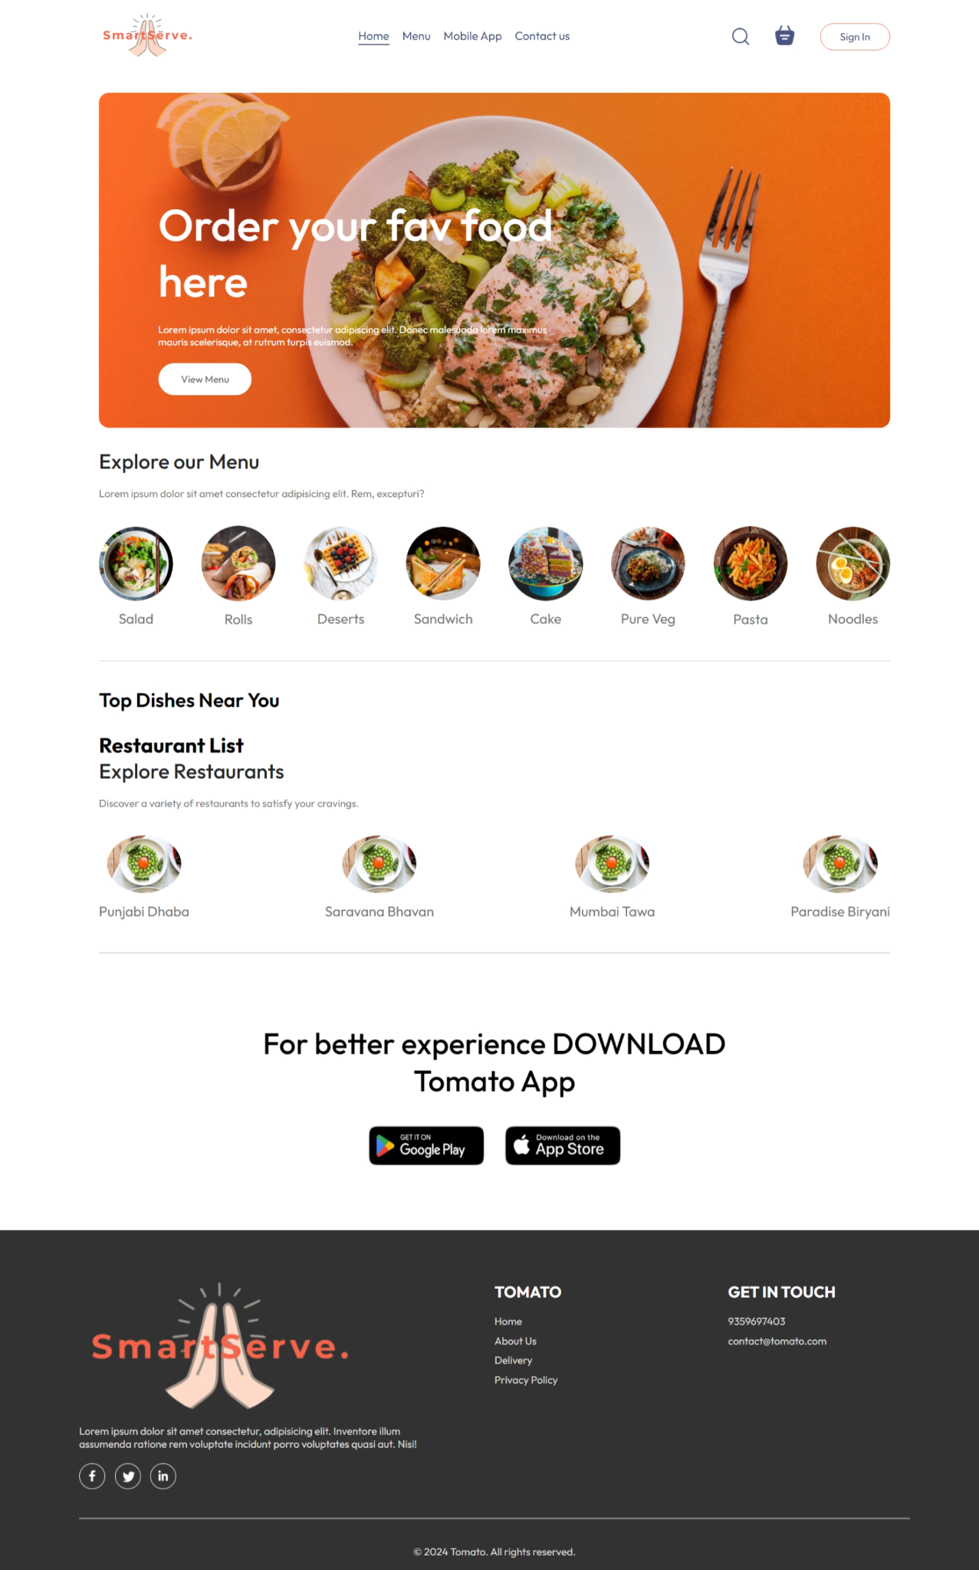

*Fig. : Home Page*

b. Bidding Process



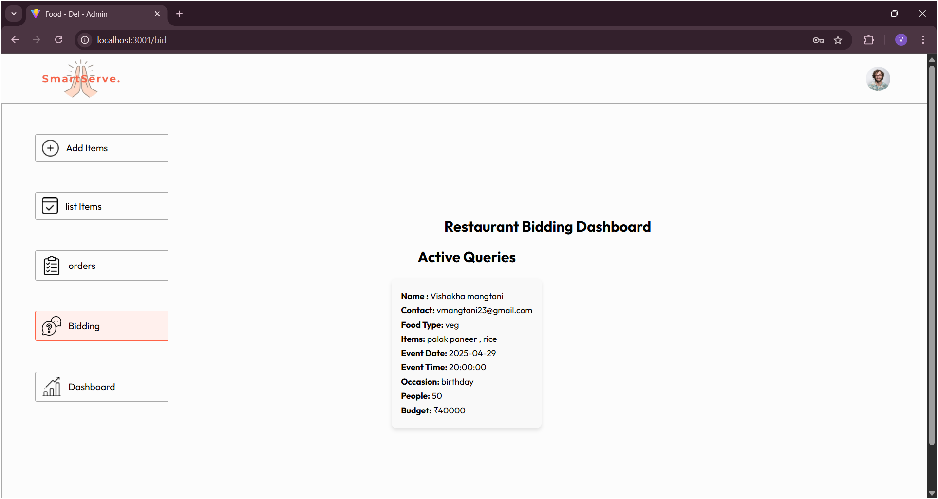



c. Chatbot Implementation





*Fig. : Chatbot Implementation*

d. Dashboard for Restaurant Analysis



*Fig. : Dashboard for Restaurant Analysis*

e.Restaurant Orders



# V.Conclusion and future work

SmartServe aims to redefine the food ordering experience by combining efficiency, personalization, and transparency. By integrating AI-driven features like the recommendation engine, chatbot, and real-time feedback collection, it provides users with a seamless and dynamic interface. The flexible quotation system empowers customers to make informed decisions, while the feedback system ensures continuous improvement and adaptability. These innovations not only enhance customer satisfaction but also support restaurant partners by optimizing their operations.

Despite the current success of SmartServe, there are areas that require further optimization. In the future, we aim to enhance the recommendation engine by incorporating deep learning models for better personalization and context awareness. Improving the accuracy of sentiment analysis and reducing response time for chatbot interactions will also be a focus. Additionally, expanding the platform’s scalability to handle more complex datasets and supporting larger user bases will ensure that SmartServe continues to meet the demands of its growing customer base.

##### VI.References

[1] J. Thomas and R. Patel, “Growth Trends and Digital Transformation in the Global Food Market,” *International Journal of Food and Beverage Technology*, vol. 9, no. 2, pp. 112-126, Apr. 2021.

[2] T. Khan, "A Cloud-Based Smart Expiry System Using QR Code," 2018 IEEE International Conference on Electro/Information Technology (EIT), Rochester, MI, USA, 2023.

[3] H. A. M. Wahsheh and M. S. Al-Zahrani, "Secure and Usable QR Codes for Healthcare Systems: The Case of Covid-19 Pandemic," 2021 12th International Conference on Information and Communication Systems (ICICS), Valencia, Spain, 2021.

[4] A. Alkhayyat, R. Kumar, S. Singh, R. Singh, Y. Kumar and U. Sharma, "An Online QR Code Scanner for Real-Time User Feedback and Ratings Collection with Local Web Server," 2024 11th International Conference on Computing for Sustainable Global Development (INDIACom), New Delhi, India, 2024.

[5] V. Dutt, S. M. Sasubilli and A. E. Yerrapati, "Dynamic Information Retrieval With Chatbots: A Review of Artificial Intelligence Methodology," 2020 4th International Conference on Electronics, Communication and Aerospace Technology (ICECA), Coimbatore, India, 2020.

[6] Megha Gupta, Venkatasai Dheekonda, Mohammad Masum, Genie: Enhancing information management in the restaurant industry through AI-powered chatbot, International Journal of Information Management Data Insights, Volume 4, Issue 2, 2024.

[7] M. R. Ardiansyah, J. F. Kusuma, I. S. Gumelar and M. Mentari, "The Website-Based Food Booking System Equipped with Real-Time Booking Status to Address Queuing Issues at Restaurants," 2021 International Conference on Electrical and Information Technology (IEIT), Malang, Indonesia, 2021.

[8] R. Garg et al., "NLP Based Chatbot for Multiple Restaurants," 2021 10th International Conference on System Modeling & Advancement in Research Trends (SMART), MORADABAD, India, 2021.

[9] Y. Wu, Y. Lei and L. Zeng, "Real-Valued Feedback Digital Predistortion Based on QR Decomposition Sample Selection," 2023 IEEE 6th International Conference

[10]Z. Čović, Ü. Viktor, J. Simon, D. Dobrilović and Ž. Stojanov, "Usage of QR codes in web based system for the electronic market research," 2016 IEEE 14th International Symposium on Intelligent Systems and Informatics (SISY), Subotica, Serbia, 2021

[11]X. Wei and C. Guo, "Research on Bid Evaluation Model in the Bidding Management for Power Grid Corporations," 2017 International Conference on Computing Intelligence and Information System (CIIS), Nanjing, China, 2017.

[12]V. N.A, T. H. Babu, V. G. Kiran, R. M. Balakrishnan and S. Bhaskaran, "Prompt Palate: A Prompt-Based Restaurant Recommendation System with Scheduling and Chatbot Integration," 2024 8th International Conference on Computational System and Information Technology for Sustainable Solutions (CSITSS), Bengaluru, India, 2024.

[13]Mr. Mhashilkar Suraj, Dr. Sonali Jadhav, “BID TO ORDER – A MODERN DIGITAL WAY OF FOOD AND BEVERAGE ORDERING SYSTEM IN RESTAURANT AROUND PUNE CITY (INDIA) ”International Research Journal of Modernization in Engineering Technology and Science,Pune,India,March 2025.

[14]J. Lee, S. Kim, and H. Park, "Sentiment Analysis of Restaurant Reviews Using Deep Learning," *IEEE Transactions on Affective Computing*, vol. 12, no. 3, pp. 567–576, Jul.–Sept. 2021.

[15]A. Kumar, R. Gupta, and P. Sharma, "Reinforcement Learning for Personalized Restaurant Recommendations," *IEEE Transactions on Neural Networks and Learning Systems*, vol. 35, no. 2, pp. 1234–1245, Feb. 2024.

[16]S. Patel, A. Kumar, and R. Gupta, "AI-Driven Bidding Strategies for Restaurant Service Optimization," *IEEE Transactions on Artificial Intelligence*, vol. 9, no. 4, pp. 567–578, Apr. 2023.

[17]S. A. Shetty, S. K. Sharma, and P. N. Kanjirath, "AI-based Automated Bidding System for Restaurant Order Management," *IEEE Transactions on Intelligent Systems*, vol. 32, no. 1, pp. 45–56, Jan. 2023.

[18]A. M. Joshi, R. A. Verma, and P. S. Saxena, "AI-Driven Recommendation Engine for Personalized Restaurant Choices," *IEEE Access*, vol. 12, pp. 67890–67902, Jun. 2023.

[19]T. G. Rani, P. V. Jain, and A. N. Sharma, "Integrating QR Code-Based Feedback Collection with Sentiment Analysis for Service Improvement in Food Industry," *IEEE Transactions on Industry Applications*, vol. 60, no. 4, pp. 789–799, Apr. 2023.

[20]R. V. Sharma, N. K. Reddy, and M. K. Kumar, "Real-time Customer Feedback Collection through QR Code and Sentiment Analysis for Restaurants," *IEEE Transactions on Consumer Electronics*, vol. 70, no. 1, pp. 43–56, Jan. 2024

**B.Plagiarism Report of Paper**

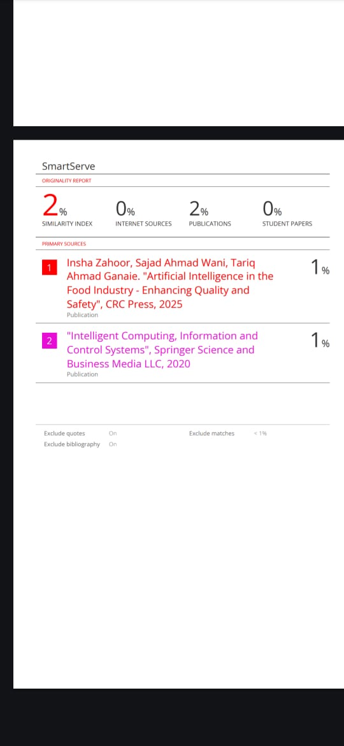

**C**. **Project review sheet**

Review - 1 Sheet

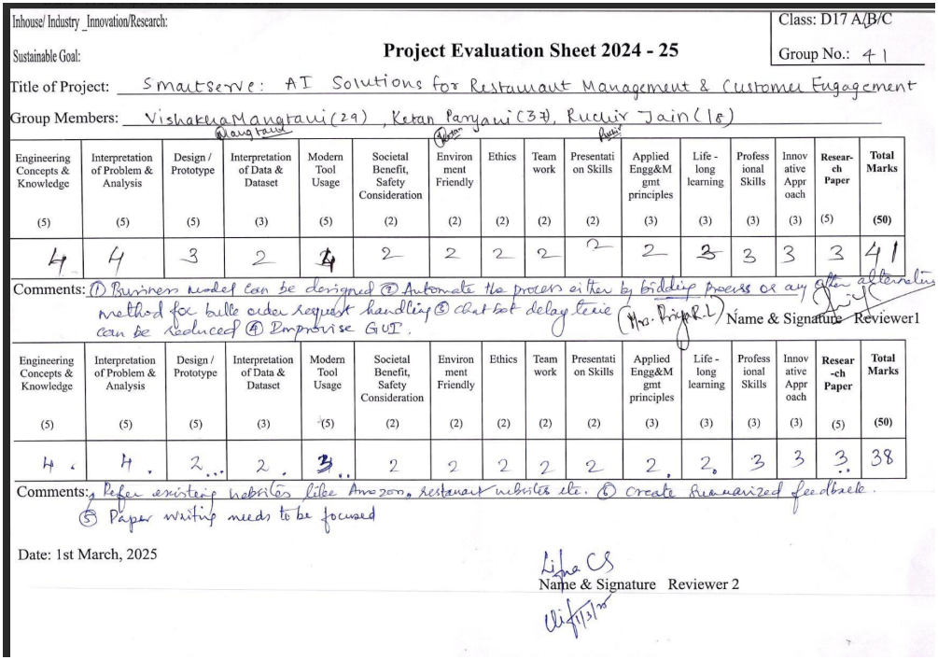

Review - 2 Sheet

